AFMech suite Guide

Author: Massimiliano Galluzzi

E-mail: galluzzi@siat.ac.cn



# Introduction

AFMech Suite is a software composed by 5 interacting interfaces in order to analyze AFM indentation data connected to morphology such as Force Volume or Force Mapping. This suite is written in Matlab language using event/object programming to provide an alternative tool for basic or advanced analysis of AFM force volume. The analysis is real-time allowing the user to be in control in each step of analysis and eventually interact (changing parameters, graphical representations) during the process.

The standard user should be from AFM beginner level to expert level with nanomechanics experience, anyway the graphical user interface does not require knowledge of Matlab language.

Interfaces are interacting in order to manipulate and visualize data where morphology, adhesion and mechanical properties are often interconnected. The interfaces are described as:

1. Therm&Calib: interface dedicated to thermal noise and optical sensitivity calibration.
2. Morphology: interface dedicated to topography, flattening and masking.
3. Adhesion: interface dedicated to analyze retracting tip adhesive behavior.
4. Mechanical: interface dedicated to Young’s modulus, finite thickness correction.
5. Advanced: interface dedicated to profile, tomography, hyperspectrum and external data compare.

After the analysis user can export all graphical results using several formats. Moreover, the software can create custom metadata to save time during analysis or quickly reload previous analysis.

The purpose of this manual is to help the unfamiliar user to perform the analysis using all the software functions, and mainly to explain/justify the operations behind buttons and menus. References to recent literature will help the interested user to find additional material and explanation about nanomechanics by AFM. During analysis, hints and warnings will help the user to perform a proper analysis.

If any problem or bugs regarding the software is experienced by the user, please contact the authors in order to solve it and improve AFMech Suite continuously. Software will be freely available on e-mail request to the authors.

List of commonly used abbreviations:

* AFM --- Atomic Force Microscopy
* FV --- Force Volume
* FC --- Force Curve
* E --- Young’s Modulus
* **[button]** --- Buttons name on interface, between square brackets
* **<edit>** --- Edit or menu control, between angular brackets

# Installation

If Matlab 2017Ra or Matlab Runtime Environment (MRE) version 9.2 is already installed in the operative system, ‘AFMech_suite’ main file can be used to start the software immediately.

MRE version 9.2 can be downloaded also from: <https://www.mathworks.com/products/compiler/matlab-runtime.html> or simply use the following direct links specific for different operative systems: <http://ssd.mathworks.com/supportfiles/downloads/R2017a/deployment_files/R2017a/installers/win64/MCR_R2017a_win64_installer.exe> (for windows), <http://ssd.mathworks.com/supportfiles/downloads/R2017a/deployment_files/R2017a/installers/glnxa64/MCR_R2017a_glnxa64_installer.zip> (for linux), <http://ssd.mathworks.com/supportfiles/downloads/R2017a/deployment_files/R2017a/installers/maci64/MCR_R2017a_maci64_installer.dmg.zip> (for mac OS). When Matlab runtime environment is installed ‘AFMech_suite’ can be launched as standalone software. Technical details are collected in readme.txt in the downloadable archive.

# Data Import

Therm&Calib requires data in a special format described in the next section

For Morphology, Adhesion and Mechanical the following formats are supported:

**Bruker**: raw data from Force Volume or Quantitative Nanomechanical Analysis (QNM)

**Asylum Research**: raw data (.ARDF) cannot be exported because company is not disclosing structure of header; therefore, the following steps must be performed to open data in AFMechSuite.

1. Open .ARDF using IGOR Pro with Asylum Research plug-in
2. Save the morphology file in ‘.ibw’ using ‘save as…’ command
3. Open the ‘Master Force Panel’, in ‘Modify’ interface select ‘save all’ as .ibw

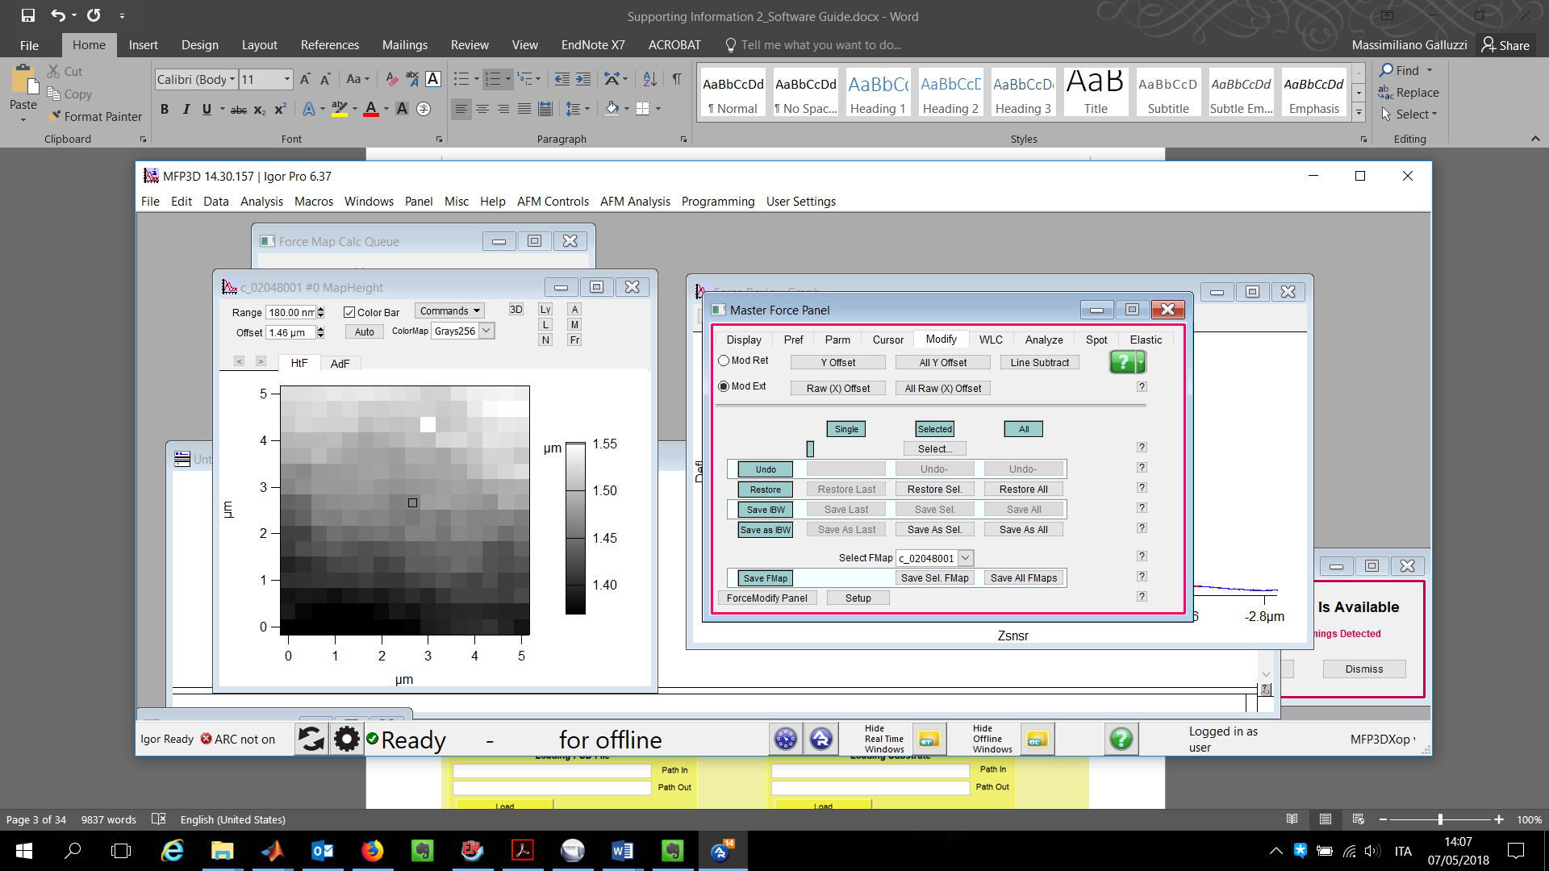

1. Morphology and all the force curves set in .ibw must be set in a separate folder. Notice each force curve will be with name: LinexxxxPointyyyy, where xxxx and yyyy are respectively number of row and number of column.
2. DO NOT add any other file in the folder representing the force volume data
3. Open in AFMech Suite by selecting a single .ibw in Force Volume folder.

**Generic ASCII:** a generic set of data in .txt ASCII format can be opened in AFMech Suite following a specific format and ordering:

1. Morphology file must be converted in ASCII with numerical values representing Height of surface in nanometer with N x N ordering. Only numeric data, no header allowed. Name: image.txt
2. Every force curve must be converted in ASCII represented by 2 columns: Distance (nanometer), Deflection (voltage). Name of single files should abide the following strict nomenclature: LinexxxxPointyyyy_A.txt (for approaching data) LinexxxxPointyyyy_R.txt (for retracting data); where xxxx and yyyy are respectively number of row and number of column.
3. Every force curve must have the same number of data points. Collect morphology and all force curves data in a separate folder.
4. DO NOT add any other file in the folder representing the force volume data
5. Open in AFMech Suite by selecting a single .ibw in Force Volume folder.

**JPK, Keysight:** work in progress

# Therm&Calib Interface

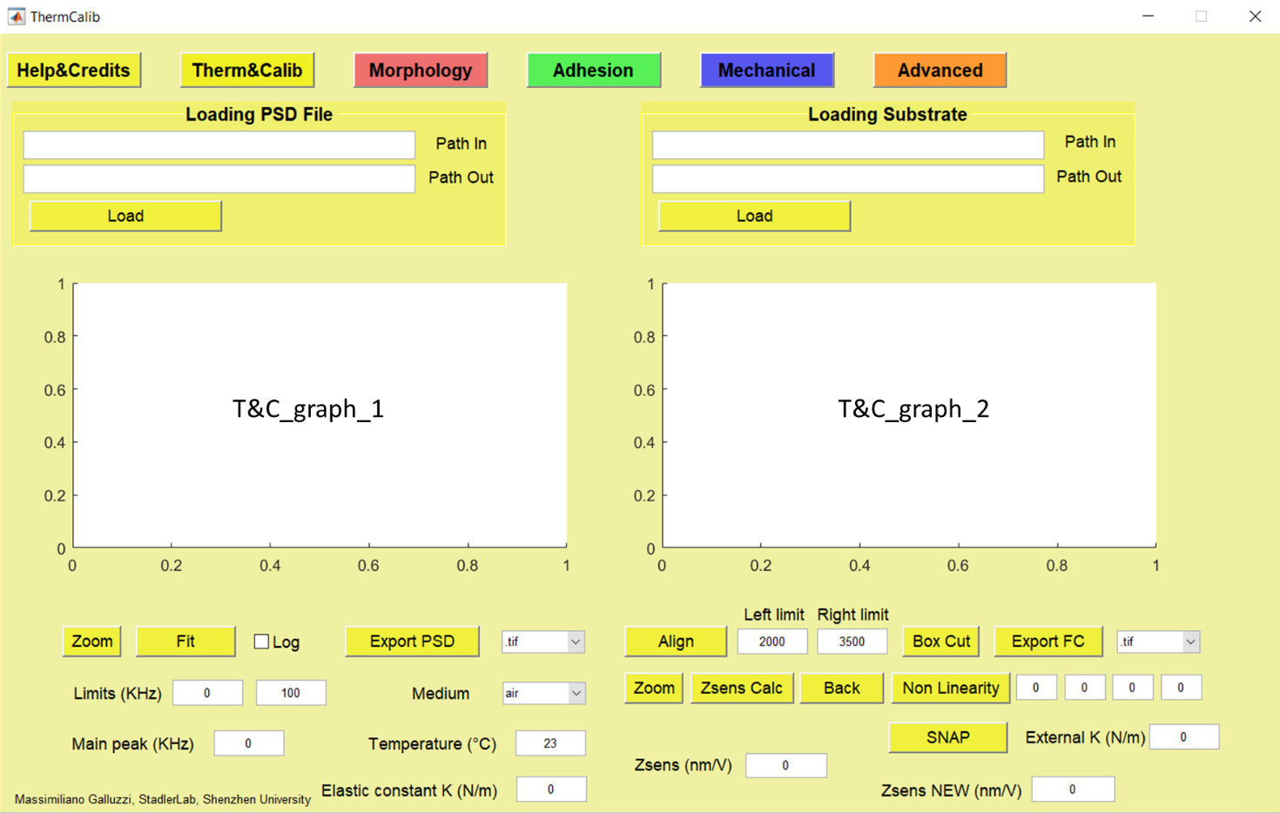

**Fig.1 Therm&Calib interface before loading data**

Therm&Calib interface is used to visualize and perform operations on the calibration analysis of the cantilever, before or after mechanical tests. Analysis will be focused in obtaining 1) Elastic constant K (N/m) from Thermal noise measurements in air or liquid (fig.1 left part) and 2) calculation of optical lever sensitivity Zsens (nm/V) from FC or FV on rigid, undeformable substrates (with negligible indentation, fig.1 right). Therm&Calib allows the user to use advanced features such as: photodetector non-linearity correction and SNAP procedure1, in order to produce high precision results.

## Elastic constant calibration: thermal noise

The first part of Therm&Calib interface is dedicated to thermal noise analysis. Detailed works about thermal noise calibration are available elsewhere.2-7 Briefly, the natural thermal vibration of AFM cantilever are recorded and analyzed in order to retrieve the elastic constant. Using the theorem of energy equipartition for single harmonic oscillators eq.1A and the properties of the Fourier’s transform eq.1B, the elastic constant can be found integrating the power spectral density PSD of cantilever vibrations; where kB is the Boltzman constant and T the absolute temperature.

$\frac{1}{2}k〈x^{2}〉=\frac{1}{2}k_{B}T k=\frac{k_{B}T}{\int_{-∞}^{+∞}{PSDdω}}$ eq(1A, B)

If thermal noise measurement is performed in air, the single harmonic oscillator model eq.2A is the appropriate choice to fit experimental PSD data. Parameters, such as zero frequency amplitude A, resonance frequency 0 and quality factor Q; can be retrieved to calculate k (eq.2B)

${PSD}^{SHO}= A^{2}{ω_{0}}^{4}\frac{1}{{\left({ω_{0}}^{2}-ω^{2}\right)}^{2}+\frac{{{ω_{0}}^{2}ω}^{2}}{Q^{2}}}+C k_{SHO}=\frac{{2k}_{B}T}{πω_{0}QA^{2}}$ eq(2A,B)

PSD measurements in water are resulting in more damped oscillation (lower Q), so Lorentz model is more favourable for data analysis using respectively eq.3A and eq.3B.

${PSD}^{Lorentz}=\frac{A^{2} {ω_{0}}^{2}}{4Q^{2}} \frac{1}{{\left(ω{-ω}_{0}\right)}^{2}+\frac{{ω_{0}}^{2}}{4Q^{2}}}+C$ $k_{Lorentz}=\frac{k_{B}T}{\frac{A^{2}ω_{0}}{2Q}*\left[\frac{π}{2}+\tan^{-1}\left(2Q\right)\right]}$ eq(3A, B)

Additional correction **<Ampl/Defl correction>** can be applied internally, taking into account that modes of vibration of a free-end and a supported/constrained cantilever are different. So, the zSENS measured in contact with a FC on a rigid substrate must be corrected in order to give the right conversion (1.09) for amplitude oscillation of free end oscillator.8 This correction, **<Ampl/Defl correction>**, is optional because most of the modern AFM acquisition software are automatically applying the same correction on exported data.

In the panel ‘Loading PSD File’ **[Load]** button allows to load thermal noise power spectral distribution files (see fig.1). The PSD file must be a .txt containing 2 columns with Frequency (kHz) and Power spectrum (pm2/Hz). The input file is based on the structure of the .txt exported from direct thermal noise Bruker acquisition software (🡪 export xz data). **[Load]** can use the complete identifier of the file (location directory + file name) contained in **<Path In>** edit. If **<Path In>** is empty or locating a directory, a menu choice is appearing in order to select the input file. **<Path Out>**, the edit string for the export/saving directory, is automatically updated accordingly with **<Path In>** selection, but can be user-overwritten in order to change the output directory.

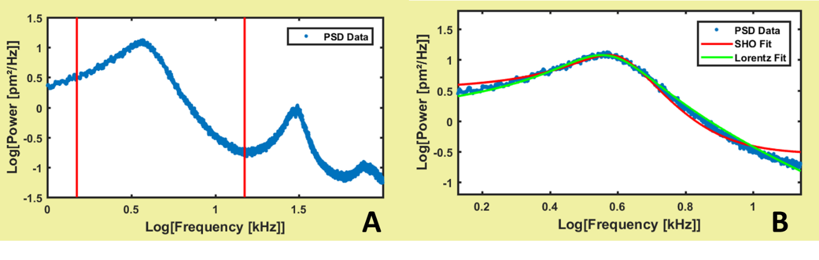**Fig.2 A) Example of PSD of MLCT_A soft cantilever in water using log-log scale. B) Zoom on the first resonance peak highlighting the single harmonic oscillator (SHO) and Lorentz fit.**

After loading, PSD data could appear in T&C_graph_1 (see fig.1) as in fig.2A. A log-log representation can be activated using **<log>** checkbox. Red vertical lines in fig.2A represent the limits of the PSD fitting procedure and can be controlled using **<Limits (kHz)>** left and right. As shown in eq.1 the temperature of environment during thermal noise measurement must be measured externally and updated in **<Temperature °C>**. **[Fit]** button is triggering the fitting procedure and calculating elastic constant k (N/m), frequency of the main peak (kHz). Results from SHO and Lorentz analysis can be visualized graphically on T&C_graph_1, for example fig.2B. Numerical values of elastic constant k can be chosen between SHO and Lorentz variating the thermal noise environment **<medium>**: air for SHO and water for Lorentz.

During all the analysis, T&C_graph_1 can be zoomed in or out entering in zoom mode after pressing **[zoom]**. Left-click of mouse allows zooming in while right-click is zooming out; any keyboard input is then releasing the zoom mode.

After analysis, the elastic constant value will be automatically updated in Mechanical and Adhesion interfaces.

## Optical lever sensitivity calibration: Zsens

The second part of Therm&Calib interface can be used for the calibration of optical lever sensitivity, briefly, zsens. The importance of zsens (nm/V) is related to the conversion of raw AFM force spectroscopy measurements (Voltage-V vs. Piezo displacement-Zpiezo ) in Force-F vs. Indentation curves for mechanical and adhesion analysis.9

The relations in order to perform the conversion are described in eq.4:

$D=z_{sens}*∆V F=D*k δ=-\left(z_{piezo}-D-X_{C}\right)$ eq(4A, B, C)

where D, V, , Zpiezo and XC represent the cantilever deflection (nm), deflection (V), indentation (nm), piezo displacement and contact point coordinate.

Before any spectroscopy experiment and for thermal noise measurement described previously, force curves on rigid ( negligible) surface must be used to retrieve zsens correctly. In the panel ‘Loading Substrate’ **[Load]** button allows to load a single force curve or FV raw file acquired on rigid surface (see fig.1). If a FV file is loaded all the operations and calibration will act on average curve. **[Load]** can use the complete identifier of the file (location directory + file name) contained in **<Path In>** edit. If **<Path In>** is empty or locating a directory, a menu choice is appearing in order to select the input file. **<Path Out>**, the edit string for the export/saving directory, is automatically updated accordingly with **<Path In>** selection, but can be user-overwritten in order to change the output directory.

After loading, several operations can be performed to clean and refine raw data, finally, obtaining zsens value. **[Align]** button is correcting the horizontal non-contact part defined between **<Left limit>** and **<Right limit>** (see fig.3A and fig.3B).Long-range interactions, such as electrostatic, should be excluded during baseline alignment procedure. **[Box Cut]** allows to create a box on T&C_graph_2 in order to erase outliers points and cut undesired FC parts from analysis. Outliers are usually found in FV at the end of FCs due to morphological inhomogeneities and acquisition errors. Finally, **[Zsens Calc]** is triggering a cursor to select the contact part after jump-in event. The contact part, being selected, will be highlighted in red, helping visualization (fig.3C). Keyboard input is then prompting the calculation leading to zsens value and displaying results as in fig.3D.

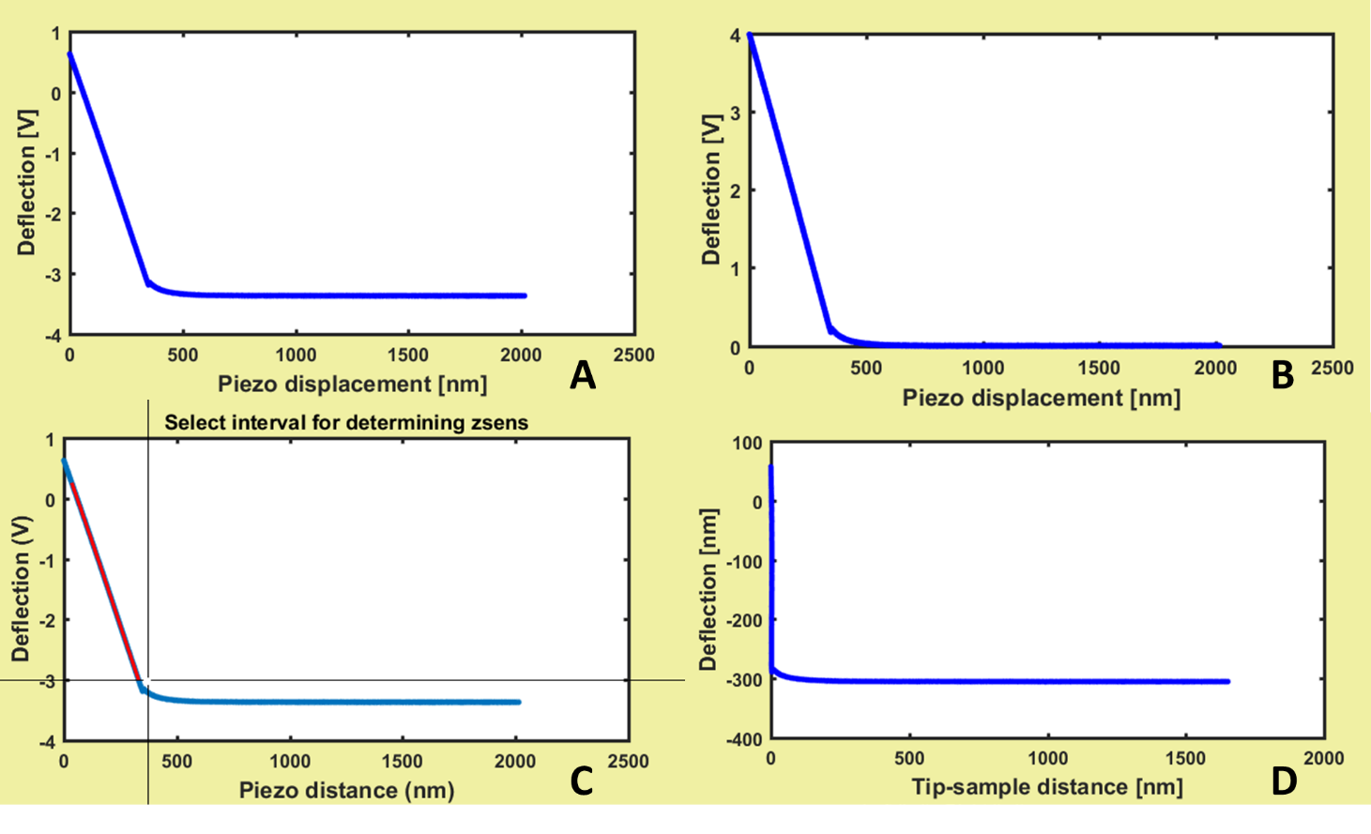**Fig.3 A) raw FC just acquired B) FC after alignment for baseline correction C) Selection of interval for zsens calculation D) final representation of FC after zsens calibration. To be noticed the y and x axis: Deflection[V]🡪Deflection [nm] and Piezo displacement[nm]🡪Tip-sample distance[nm].**

During all the analysis, T&C_graph_2 can be zoomed in or out entering in zoom mode after pressing **[zoom]**. Left-click of mouse allows zooming in while right-click is zooming out; any keyboard input is then releasing the zoom mode.

**[Back]** button is undoing the zsens calculation operated by **[Zsens Calc].**

After analysis, the zsens value will be automatically updated in Mechanical and Adhesion interfaces.

## Non linearity correction

In most the commercially available AFM, the photodetector limits are -12V and +12V. Reaching the limit, the signal undergoes saturation with continuity, meaning that for high voltage deflection will be apparently bended towards saturation value. Around the center of photodetector (usually between ±2V), the deflection will be linear and can be used for zsens calculation. Especially when the probe is indenting a surface, if big deflection is used, non-linear effects can be misleading. This non-linear effect can be corrected using **[Non Linearity]** button, in order to use a wider range of deflection voltages.

As an example in this section, FC of fig.3 was zoomed in showing 4 nm of non-linearity between -4V and 0V, fig.4A. [**Non Linearity]** is allowing a cursor to select the linear part of deflection like in fig.4B. The second step is to select the overall contact part in order to be corrected (fig.4C): the bending is fitted with a 3rd grade polynomial curve. If the fitting is following the experimental data, the correction can be accepted and applied. **[Zsens Calc]** after **[Non Linearity]** will result more precisely, as shown in fig.4D.

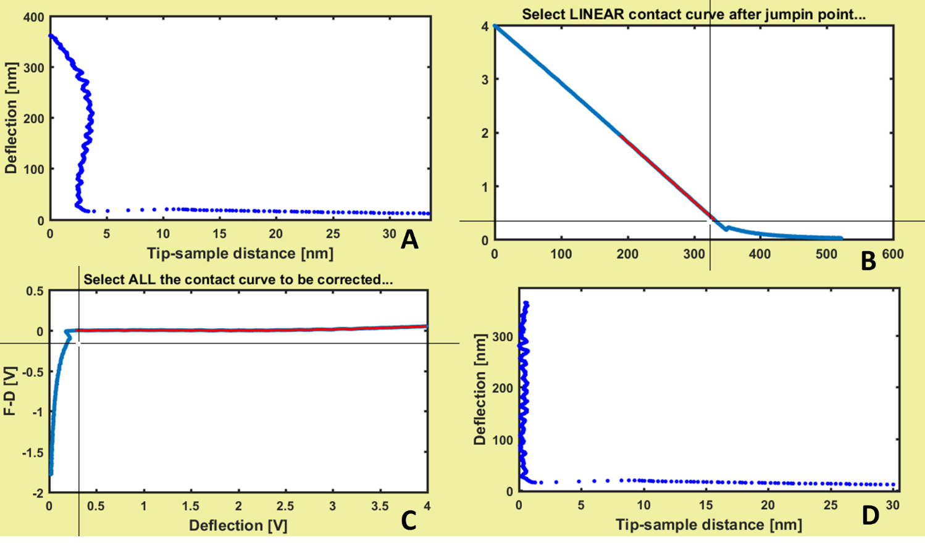

**Fig.4 A) zoom of FC of** **fig.3** **showing non-linearity effect. B) first step of correction selecting the linear part of the curve after jump-in event. C) second step of correction selecting all the contact part (highlighting non-linearity). D) Final results after zsens calculation.**

After non-linearity correction, 4 parameters (coefficients of polynomial correction) will be automatically updated in Mechanical and Adhesion interfaces.

## Standardized Nanomechanical AFM Procedure: SNAP

A standardized Nanomechanical procedure (SNAP) was recently introduced,1 discussing problematics in nanomechanical measurements experienced in 11 different AFM labs across Europe and participating to COST Action TD1002, European network on applications of atomic force microscopy to nanomedicine and life sciences. The main issue was about the error/imprecision during optical lever sensitivity calibration, then propagating in thermal noise calculation. Through an external, independent measurement of elastic constant of cantilever, **[SNAP]** can be used to modify the imprecise zsens. Elastic constant from thermal noise is depending quadratically on zsens, so eq.5 holds:

$z_{sens}^{new}=λ * z_{sens}^{old} λ = \sqrt{\frac{k_{old}}{k_{external}}}$ eq(5A, B)

If correction is detected, the new values of zsens and kexternal will be automatically updated in Mechanical and Adhesion interfaces.

## Exporting

Graphics produced in T&C_graph_1 and T&C_graph_2 can be exported during any stage of analysis using buttons **[Export PSD]** and **[Export FC]**. Exported files are automatically saved in directory designated by respective **<Path Out>** edit. Formats available are listed:

1. .tif *Tagged Image File Format* no compression, 300 dpi
2. .fig *Matlab Figure*
3. .mat *Matlab Data*, structure containing Matlab variables
4. .txt *Plain text with no special formatting,* data and/or fitting in columns
5. .xls *Excel* table, data and/or fitting in columns
6. .opj *Origin* table and graphs

If Matlab software is not available .fig and .mat files cannot be opened. Origin export in .opj is not creating or opening if Origin is not installed on the machine.

# Morphology Interface

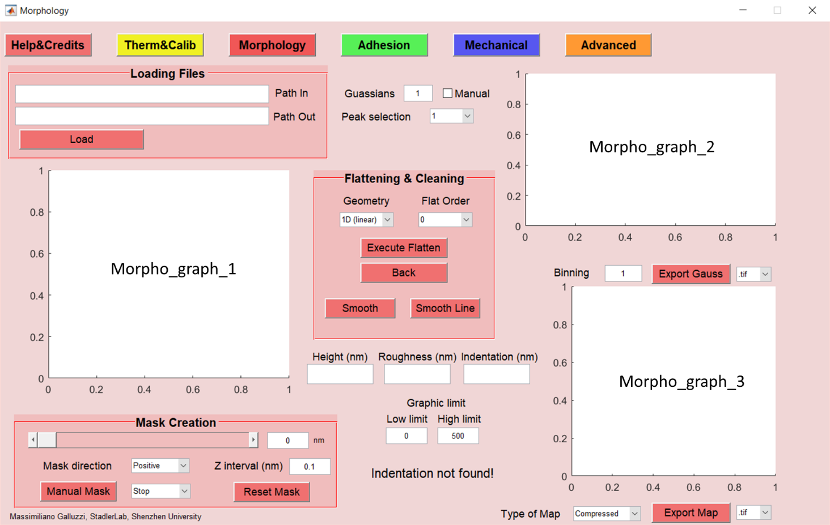

**Fig.5 Morphology interface before loading data**

Morphology interface is used to visualize and perform operations on the raw height channel after FV acquisition. Morphology is especially useful to show 1:1 correspondence with adhesion or mechanical map. Here, raw morphology can be flattened removing sample tilt or can be smoothed to reduce noise and errors. A mask can be produced manually or with automatic height leveling to help in flattening or to exclude data from analysis. The mask created here is automatically used in Mechanical, Adhesion and Advanced interfaces. Interacting morphology analysis is especially useful when finite thickness correction is applied during mechanical analysis. Finally, quantitative analysis is available using histograms and Gaussian fitting procedures.

In the panel ‘Loading Files’ **[Load]** button allows to load morphology data from raw FV files from AFM acquisition software (see fig.5). **[Load]** can use the complete identifier of the file (location directory + file name) contained in **<Path In>** edit. If **<Path In>** is empty or locating a directory, a menu choice is appearing in order to select the input file. **<Path Out>**, the edit string for the export/saving directory, is automatically updated accordingly with **<Path In>** selection, but can be user-overwritten in order to change the output directory.

After loading, raw morphology will be shown in Morpho_graph_1: operations like flattening, smoothing and masking will act on this graph, vertical scale in nanometer is automatically set by software. Quantitative histogram is shown in Morpho_graph_2 while final maps are shown in Morpho_graph_3. Here, vertical scale is user-controlled modifying ‘Low’ and ‘High’ values in **<Graphic limits>**. Final maps can be visualized (and exported): compressed morphology, real morphology, indentation and mask.

## Flattening & Cleaning

Flattening AFM morphological maps is one of the basic AFM operation in order to produce good and scientific reliable images. Sample on AFM stage is often tilted and raw images appear like fig.6A, and hardly can be used to quantitative analysis as shown in fig.6B.

To flatten the thin film of fig.6A, the substrate is individuated building a mask (see next section: Mask Creation) that covers the thin film. The purpose of flattening is to reference the height of substrate at zero, by subtracting planes or lines to the image. **[Execute Flatten]** is performing this operation, after the selection of **<Geometry>** and **<Flat Order>**. **<Geometry>** can be 1D, so line by line, or 2D planar; while **<Flat Order>** can control the polynomial degree of the fitting lines or plane. Every flattening operation is recorded and can be undone using **[Back]** until raw image is reset.

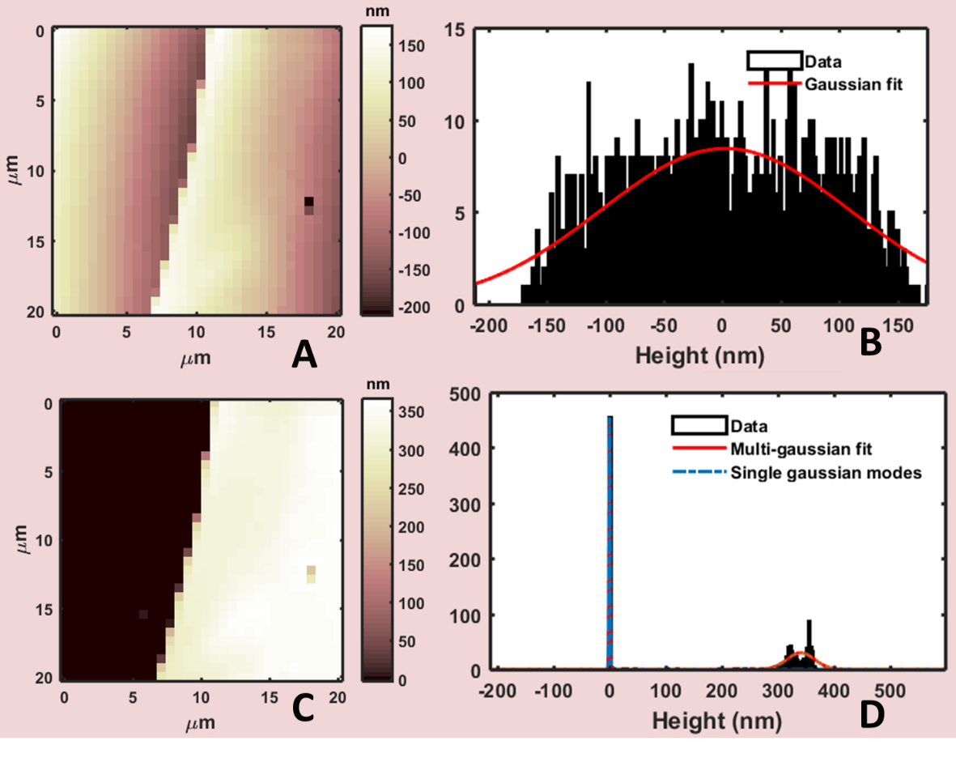

**Fig.6 A) Raw morphology image of polymeric thin film on silicon, B) Quantitative analysis of raw image. C) Morphology (compressed) of flattened image D) quantitative analysis showing substrate at zero and thickness of the film.**

Flattening operation will lead to a correct topography (fig.6C) and quantitative information can be extracted like thickness and roughness (fig.6D). More details are available in Statistical Analysis section.

If final morphology is showing local defects/artifacts or excessive noise, **[Smooth]** button can help to get rid of imperfections using a smoothing filter with 3x3 kernel. Every points of the map is substituted with the average of first neighbors, therefore 3x3 kernel (excluding points at the border). **[Smooth]** can produce better images at price of sharpness, so excessive usage must be avoided because of blurry and imprecise morphology. If the image show single separated lines outlying the rest of the image (for example produced by improper or difficult 1D flattening) **[Smooth line]** is creating a selecting cursor on Morpho_graph_1 in order to substitute the ‘bad’ line with the average of upper and lower line. Also in this case, **[Smooth line]** operation is coming at the price of losing part of data.

Morphology interface can interact with Mechanical interface in order to obtain the real morphology of the sample. In FV measurement, the height map output is produced when FC is reaching the maximum force (set up by relative trigger). The morphology after flattening is usually compressed by the force used in experiment, while real morphology should be related to zero force. Real morphology can be produced automatically adding the indentation map (the space between maximum force and zero force) to the compressed morphology. After Mechanical analysis, specifically **[CP Find]** and **[Execute]** (see Mechanical Interface chapter), indentation map is automatically uploaded and can be visualized (and exported) selecting the specific **<Map Type>** for Morpho_graph_3.

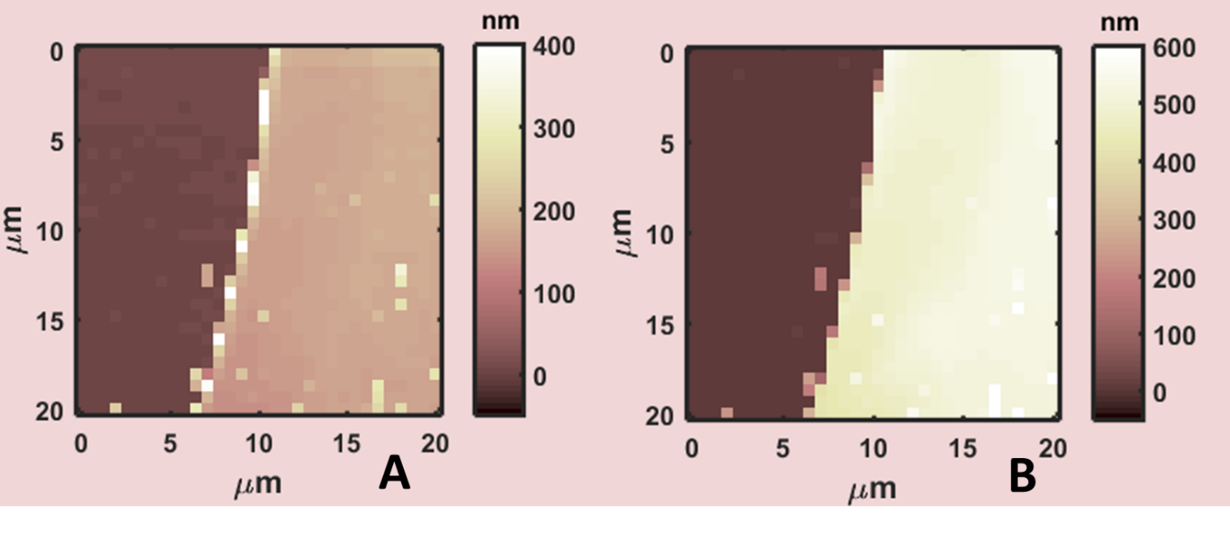

**Fig.7 A) Indentation map of fig.6 example after mechanical analysis. B) Real Morphology of polymeric thin film obtaining after adding indentation to compressed morphology (****fig.6C****).**

Quantitative information about indentation will be also updated under **<Indentation (nm)>**.

## Mask Creation

As pointed out in the previous section, the creation of a mask on morphology map is crucial for flattening and data selectivity. Mechanical properties of thin film or thin structures are influenced by the presence of hard substrate during indentation process. A finite thickness correction is available in Mechanical interface only after flattening and substrate individuation by masking it in Morphology interface.

Mask can be created in 2 ways and will be evidenced in black shadow, as shown in fig.8A. The first possibility is moving the slidebar cursor in ‘Mask Creation’ panel in order to mask all points relative to a height threshold zref (visible near the slidebar, zref is controlled by slidebar cursor). If **<Mask direction>** is selected ‘positive’ height values above threshold (z > zref) will be masked, if ‘negative’ is selected points below threshold (z < zref) will be shadowed. For complex and difficult morphologies ‘interval’ option is available masking height values outside a floating interval zint defined by **<Z Interval>** (zref-zint < z < zref+zint).

**[Manual Mask]** is allowing the selection of a rectangle on Morpho_graph_1 to create (if ‘stop’ is selected) or remove (if ‘pass’ is selected) a manual mask. Playing with ‘stop’ and ‘pass’ options, masks with complex shapes can be created (see fig.8).

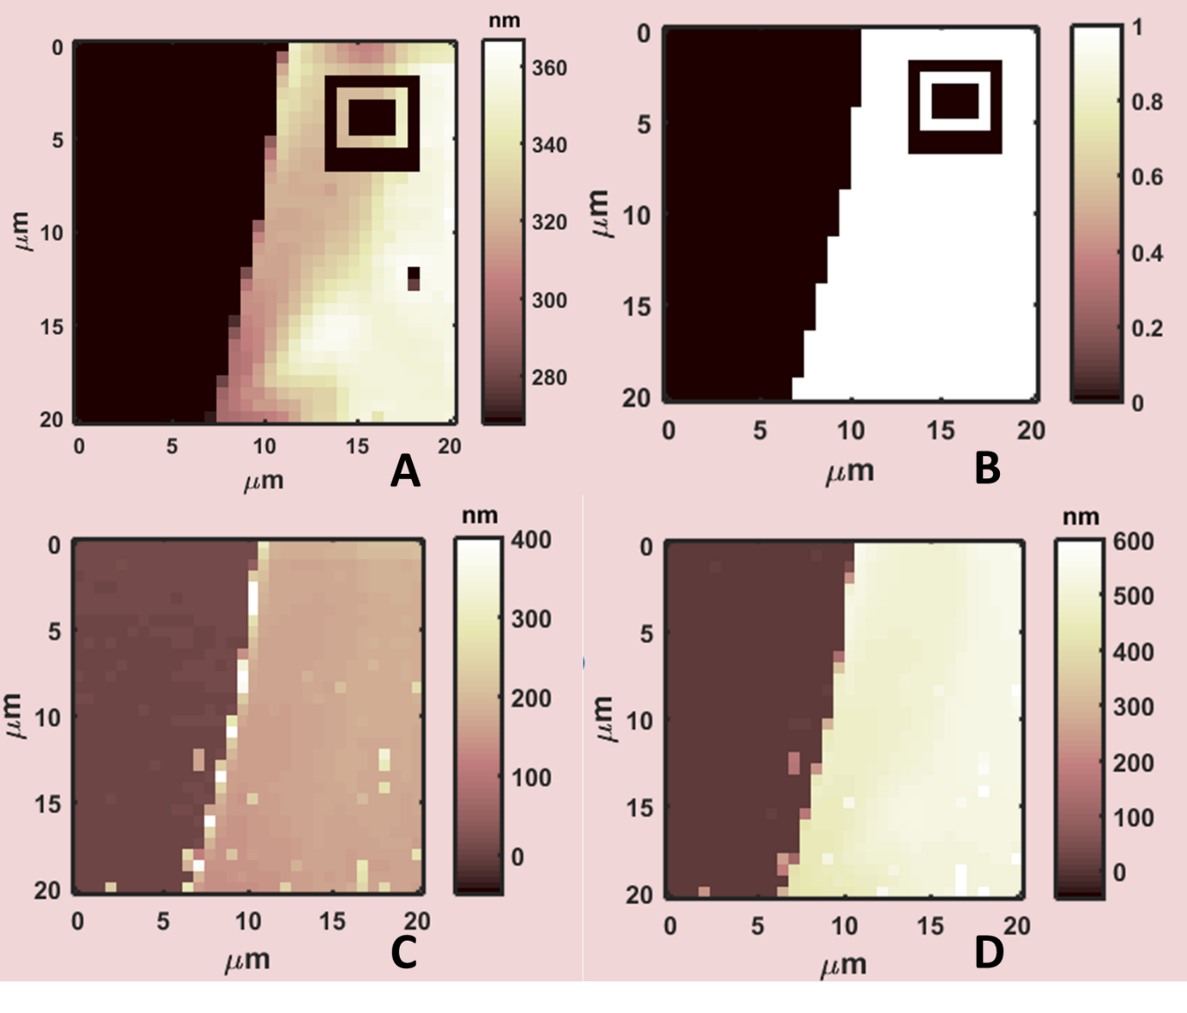

**Fig.8 A) Morphology map with mask B) Mask map**

The final mask will be used directly in Mechanical, Adhesion and Advanced interfaces: the logical mask map can be visualized (and exported) selecting the specific **<Map Type>** for Morpho_graph_3, as shown in fig.8B.

Finally, mask can be removed using the slidebar and pressing **[Reset Mask]** button.

## Statistical analysis

Statistical analysis in Morphology interface can be visualized in Morpho_graph_2, represented by the histogram of heights. **<Binning>** allows to change the size of a single bin in histogram, updating automatically the figure. For single distribution of data, like fig.9A, histogram is automatically fitted by a single Gaussian distribution. If histogram is showing more than a single peak, multi-Gaussian fit procedure will be the best choice to obtain quantitative information, selecting the number of peaks in **<Gaussians>**. Numerical results after data analysis can be selected modifying the peak number in **<Peak Selection>**. Especially for multi-Gaussian procedure, when software is not recognizing automatically distribution peaks, manual mode can be activated using checkbox **<Manual>**.

Manual mode is asking the user’s input to recognize multi-peaks positions. First, as shown in fig.9B, the interval used for Multi-Gaussian fitting must be selected (selection will be highlighted in blue). Then, starting positions must be individuated using left-click mouse: first, the center and height of distribution (triangles in fig.9C), then, width at semi-height of distribution (squares in fig.9C). The operation must be repeated for every distributions selected in **<Gaussians>**. Results could appear graphically as in fig.9D, while numerical values are will be shown under **<Height (nm)>** and controlled by **<Peak Selection>**. Value and error of **<Height (nm)>** are just the center and semi-width of the single-mode Gaussian distributions.

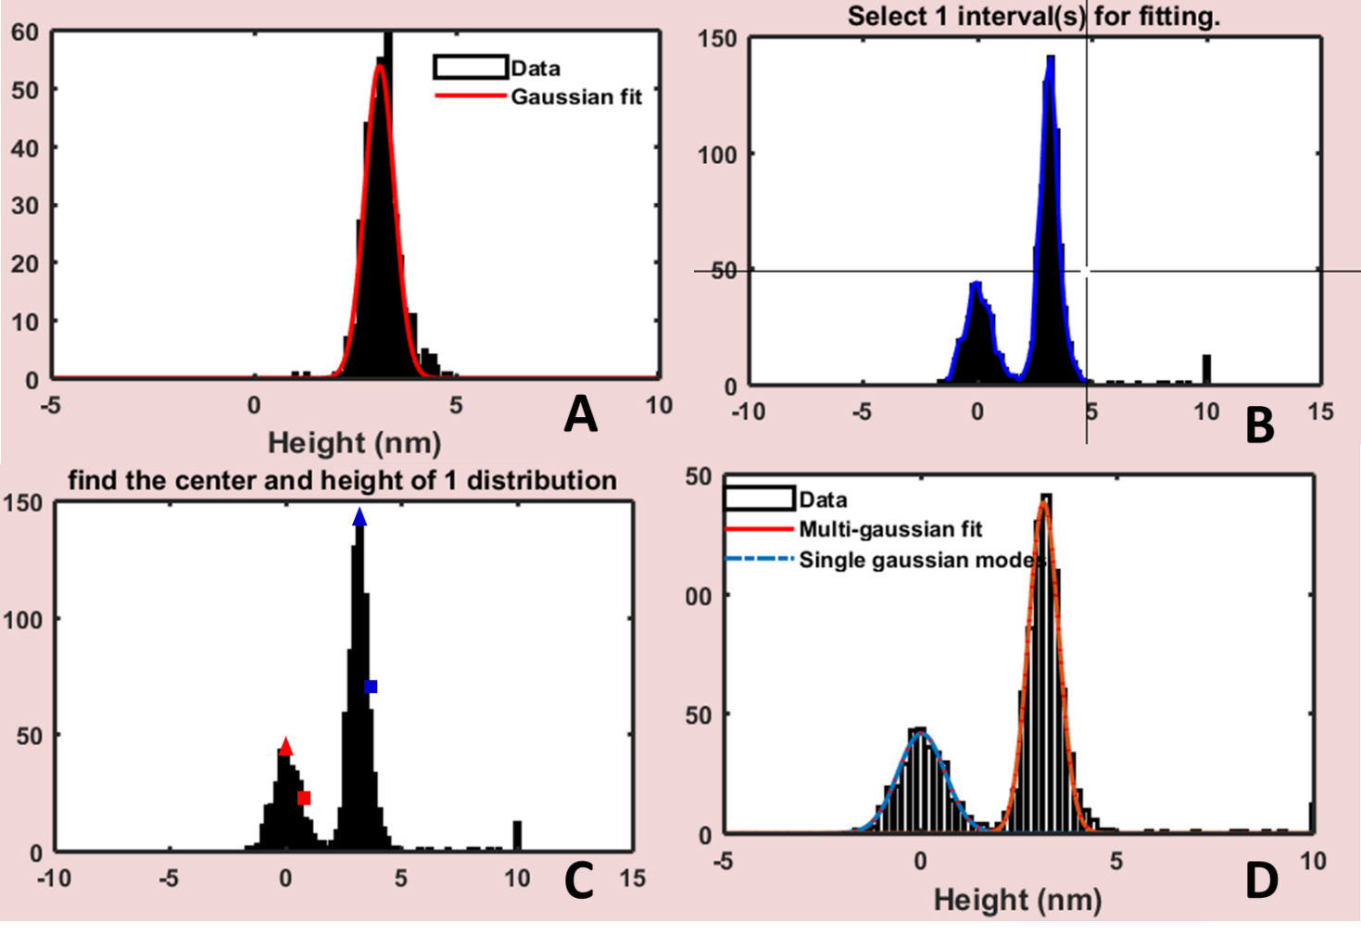

**Fig.9 A) example of histogram with single distribution data and automatic Gaussian fit. B) Selection of interval before fitting in manual mode C) peaks finding procedure for each peak: first center and height (triangles) and width at semi-height (squares) D) Final results after multi-Gaussian fitting.**

After Gaussian analysis the root mean square roughness RQ will be updated under **<Roughness (nm)>**, using the following relation:

$R_{Q}= \sqrt{\frac{1}{n}\sum_{i=0}^{n}{{\left(x_{i}-\overline{x}\right)}^{2}}}$ Eq(6)

Where n is the number of points in the map, x local height value and $\overline{x}$ the average height of plane. To be pointed out that RQ roughness in eq.6 should be the same or at least comparable with standard deviation of height.

## Exporting

Graphics produced in Morpho_graph_2 and Morpho_graph_3 can be exported during any stage of analysis using buttons **[Export Gauss]** and **[Export Map]**. Exported files are automatically saved in directory designated by respective **<Path Out>** edit.

For Gaussian analysis, using **[Export Gauss],** formats available are listed below:

1. .tif *Tagged Image File Format* no compression, 300 dpi
2. .fig *Matlab Figure*
3. .mat *Matlab Data*, structure containing Matlab variables
4. .txt *Plain text with no special formatting,* data and/or fitting in columns
5. .xls *Excel* table, data and/or fitting in columns
6. .opj *Origin* table and graphs

If Matlab software is not available .fig and .mat files cannot be opened. Origin export in .opj is not creating or opening if Origin is not installed on the machine.

Different maps in Morpho_graph_3 can be selected using <Map Type> selection:

1. *Compressed* compressed morphology at high force
2. *Indentation* indentation map after Mechanical analysis
3. *Corrected* real morphology map: Compressed + Indentation
4. *Mask*  logical map defining the mask

Using **[Export Map]**, images will be exported in the following formats:

1. .tif *Tagged Image File Format* no compression, 300 dpi
2. .fig *Matlab Figure*
3. .mat *Matlab Data*, structure containing Matlab variables
4. .tif(3D) *Tagged Image File Format*, 300 dpi, 3D representation of map
5. .fig(3D) *Matlab Figure*, 3D representation of map

# Adhesion Interface

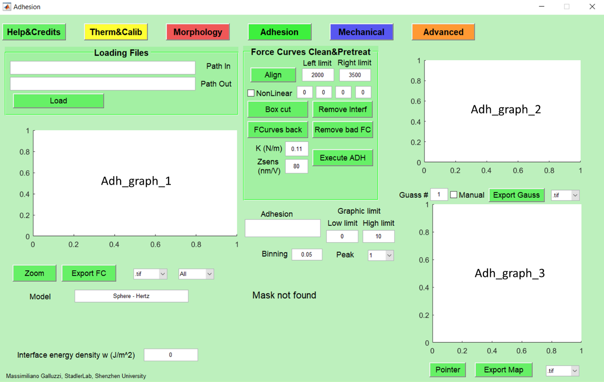

**Fig.10 Adhesion interface before loading data**

Adhesion interface is used to visualize and operate on raw FV file, focused on retracting part of force curves. Adhesion analysis is important when the contact between probe and sample is adhesive and additional interaction forces play a role during indentation. Here, raw retracting FC can be aligned, pretreated in order to produce quantitative results thanks to histograms and Gaussian fitting procedures. If analysis in other interfaces is performed, Adhesion will inherit elastic constant **<K (N/m)>**, **<Zsens(nm/V)>** from Therm&Calib, Mask from Morphology and tip geometry and model from Mechanical. Interacting adhesion analysis is especially useful when adhesive force is comparable with indentation force or just interest is focused on adhesion and interface energy density (see Statistical Analysis for more details).

In the panel ‘Loading Files’, **[Load]** button allows to load retracting force curves from raw FV files from AFM acquisition software (see fig.10). **[Load]** can use the complete identifier of the file (location directory + file name) contained in **<Path In>** edit. If **<Path In>** is empty or locating a directory, a menu choice is appearing in order to select the input file. **<Path Out>**, the edit string for the export/saving directory, is automatically updated accordingly with **<Path In>** selection, but can be user-overwritten in order to change the output directory.

After loading, raw FCs will be shown in Adh_graph_1: operations like baseline alignment, cleaning and interference removal are active on this graph. Quantitative histogram is shown in Adh_graph_2 while adhesion map can be visualized (and exported) in Adh_graph_3. Here, vertical scale is user-controlled modifying ‘Low’ and ‘High’ values under **<Graphic limits>**.

## Adhesion analysis

After loading, several operations can be performed to finally obtain adhesion force values. **[Align]** button is correcting the horizontal non-contact part defined between **<Left limit>** and **<Right limit>** (see fig.12A).Long-range interactions, such as electrostatic, should be excluded during baseline alignment procedure. **[Box Cut]** allows creating a box on Adh_graph_1 in order to delete outliers points and cut undesired FC parts from analysis. Outliers are usually found in FV at the end of FCs due to morphological inhomogeneities.

Especially when reflective samples are investigated, the laser reflected from cantilever is interfering with part of laser reflected from surface. Interference effect appears as a sinusoidal oscillation in the non-contact part (see fig.11A) leading to imprecisions if amplitude is not negligible. In Adhesion and Mechanical interfaces, FCs can be pretreated after **[Align]** in order to remove (or decrease) interference artifacts. **[Remove Interf]** button let the user select the non-contact part, far enough from jump-in event, defining the interval of sinusoidal fit (see fig.11B). Then, user must select by left-click a series of adjacent MAX and MIN from left to right direction, as shown in fig.11C; and a red line fit will appear after pressing ENTER. If the removal process is successful, non-contact part will appear as in fig.11D with no measurable oscillations.

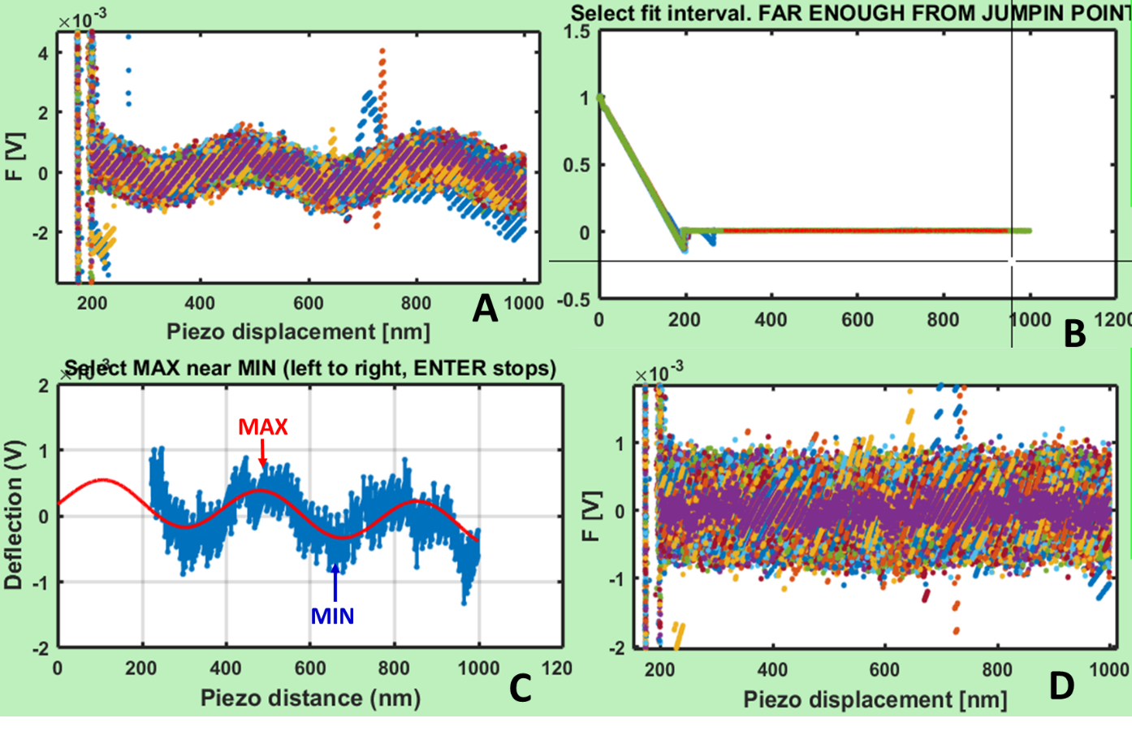

**Fig.11 A) Zoom on non-contact retracting FC showing interference, B) interval selection for sinusoidal fitting, C) MAX and MIN identification in order to perform the fitting D) results after interference removal.**

If a retracting FC is not good, due to local sample defects or acquisition problems, can be removed using button **[Remove bad FC]**. Selected ‘bad’ FC is substituted with average of first neighbors curves.

After pretreatment described before, **[Execute ADH]** is triggering a series of operations and updates with single click. First, raw force curves as in fig.12A are converted from Deflection [V] vs. Piezo Displacement [nm] in Force [nN] vs. Tip-sample Distance [nm] as shown in fig.12B. Differently from Mechanical analysis, the contact point is defined as the minimum of adhesion well. Although for soft material or complex surface, the contact point could be erroneous, a wrong position is not influencing mechanical properties because the analysis is performed on the approaching curves (Mechanical interface). Force curves approaching + retracting are anyway aligned and available to be exported in Advanced interface (see fig.20A).

Adhesion is effectively defined as the force necessary to overcome the interaction between probe and surface after contact, so, the difference between cantilever in rest position (far from surface) and the minimum of adhesion well. **[Execute ADH]** is then using adhesion values to perform quantitative analysis (see next part: Statistical analysis) and draw the adhesion map as in fig.12C.

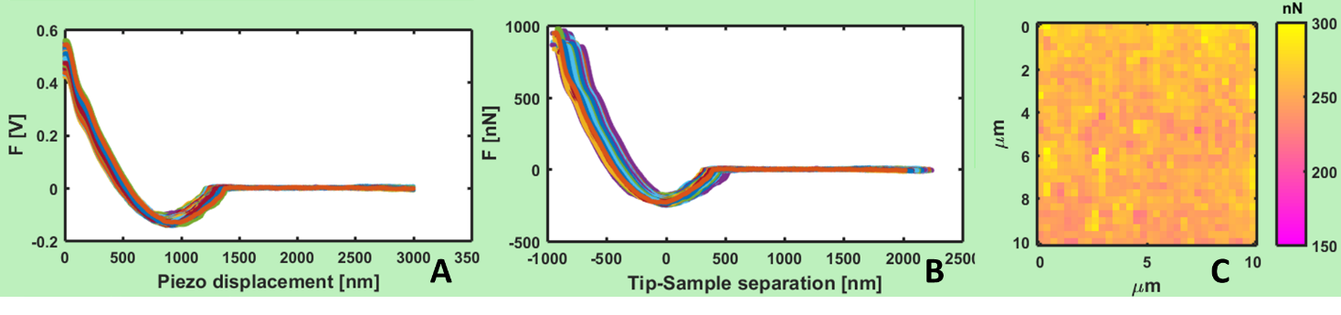

**Fig.12 A) Example of adhesive retracting force curves on PDMS in humid air after pretreatment analysis, B) same set of force curves after executing adhesion analysis, C) Adhesion map.**

During all the analysis, Adh_graph_1 can be zoomed in or out entering in zoom mode after pressing **[zoom]**. Left-click of mouse allows zooming in while right-click is zooming out; any keyboard input is then releasing the zoom mode.

Near Adh_graph_3, **[Pointer]** button allows the selection of a single point on the map selecting the respective FC on Adh_graph_1 and changing the curve number under the graph. The reverse is possible, so changing the curve number; FC position on the map will be highlighted. Selecting ‘All’, Adh_graph_1 shows all the curve together, ‘Ave’ shows the average curve.

## Statistical analysis

Statistical analysis in Adhesion interface can be visualized in Adh_graph_2, represented by the histogram of adhesion. **<Binning>** allows to change the size of a single bin in histogram, updating automatically the figure. Like in Morphology and Mechanical interfaces, if histogram is showing more than a single peak, multi-Gaussian fit procedure will be the best choice to obtain quantitative information, selecting the number of peaks in **<Gaussians>**. Numerical results after data analysis can be selected modifying the peak number in **<Peak Selection>**. Especially for multi-Gaussian procedure, when software is not recognizing automatically distribution peaks, manual mode can be activated using checkbox **<Manual>**.

Manual mode is asking the user’s input to recognize multi-peaks positions. First, as shown in fig.13A, the interval used for Multi-Gaussian fitting must be selected (selection will be highlighted in blue). Then, starting positions must be individuated using left-click mouse: first, the center and height of distribution (triangles in fig.13B), then, width at semi-height of distribution (squares in fig.13B). The operation must be repeated for every distributions selected in **<Gaussians>**. Results could appear graphically as in fig.13C, while numerical values are will be shown under **<Adhesion>** and controlled by **<Peak Selection>**. Value and error of **<Adhesion>** are just the center and semi-width of the single-mode Gaussian distributions.

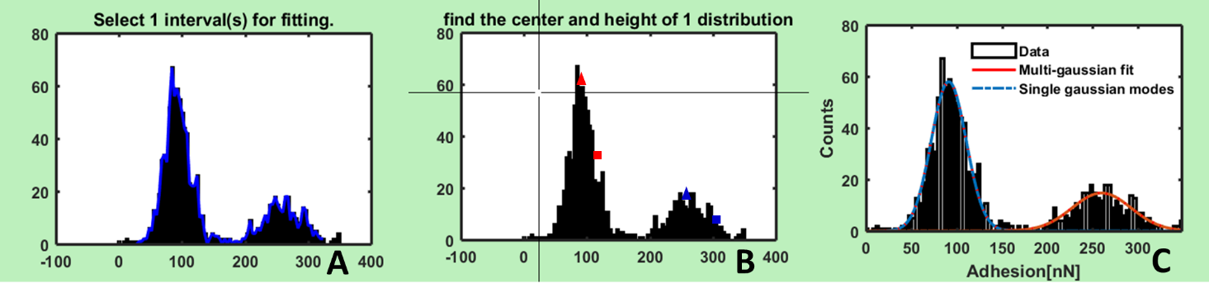

**Fig.13 A) Selection of interval before fitting in manual mode B) peaks finding procedure for each peak: first center and height (triangles) and width at semi-height (squares) C) Final results after multi-Gaussian fitting.**

Average adhesion value in **<Adhesion>** after Mechanical analysis, if a mechanical adhesive model is selected, so that **[Execute ADH]** calculates the surface energy density w (J/m2). Calculation for w are available under **<Interface energy density>** and only active for adhesive mechanical models: spherical DMT (eq.10), JKR (eq.11) and Adhesive cone (eq.13)

$w_{DMT}=\frac{F_{AD}}{2πR} w_{JKR}=\frac{{2F}_{AD}}{3πR} w_{Adh Cone}=\sqrt{\frac{πE\cot{α}F_{AD}}{54(1-ν^{2})}}$ Eq(7 A, B, C)

Where FAD, R, E, ,  are respectively average adhesion force, probe radius, average Young’s modulus, probe semi-aperture angle and Poisson’s ratio. If other mechanical models, where adhesion is not considered, are selected w will be zero. More details about derivation of eq.7 and theoretical framework can be found elsewhere.10

## Exporting

Graphics produced in Adh_graph_1, Adh_graph_2 and Adh_graph_3 can be exported during any stage of analysis using buttons **[Export FC],** **[Export Gauss]** and **[Export Map]**. Exported files are automatically saved in directory designated by respective **<Path Out>** edit.

Retracting force curves can be exported using **[Export FC],** with the possibility to choose ‘All’, ‘average’ or ‘curve #’: formats available are listed below:

1. .tif *Tagged Image File Format* no compression, 300 dpi
2. .fig *Matlab Figure*
3. .mat *Matlab Data*, structure containing Matlab variables
4. .txt *Plain text with no special formatting,* data and/or fitting in columns
5. .xls *Excel* table, data and/or fitting in columns
6. .opj *Origin* table and graphs

If Matlab software is not available .fig and .mat files cannot be opened. Origin export in .opj is not creating or opening if Origin is not installed on the machine.

For Gaussian analysis, using **[Export Gauss],** formats available are listed below:

1. .tif *Tagged Image File Format* no compression, 300 dpi
2. .fig *Matlab Figure*
3. .mat *Matlab Data*, structure containing Matlab variables
4. .txt *Plain text with no special formatting,* data and/or fitting in columns
5. .xls *Excel* table, data and/or fitting in columns
6. .opj *Origin* table and graphs

If Matlab software is not available .fig and .mat files cannot be opened. Origin export in .opj is not creating or opening if Origin is not installed on the machine.

Using **[Export Map]**, images will be exported in the following formats:

1. .tif *Tagged Image File Format* no compression, 300 dpi
2. .fig *Matlab Figure*
3. .mat *Matlab Data*, structure containing Matlab variables
4. .tif(3D) *Tagged Image File Format*, 300 dpi, 3D representation of map
5. .fig(3D) *Matlab Figure*, 3D representation of map

# Mechanical Interface

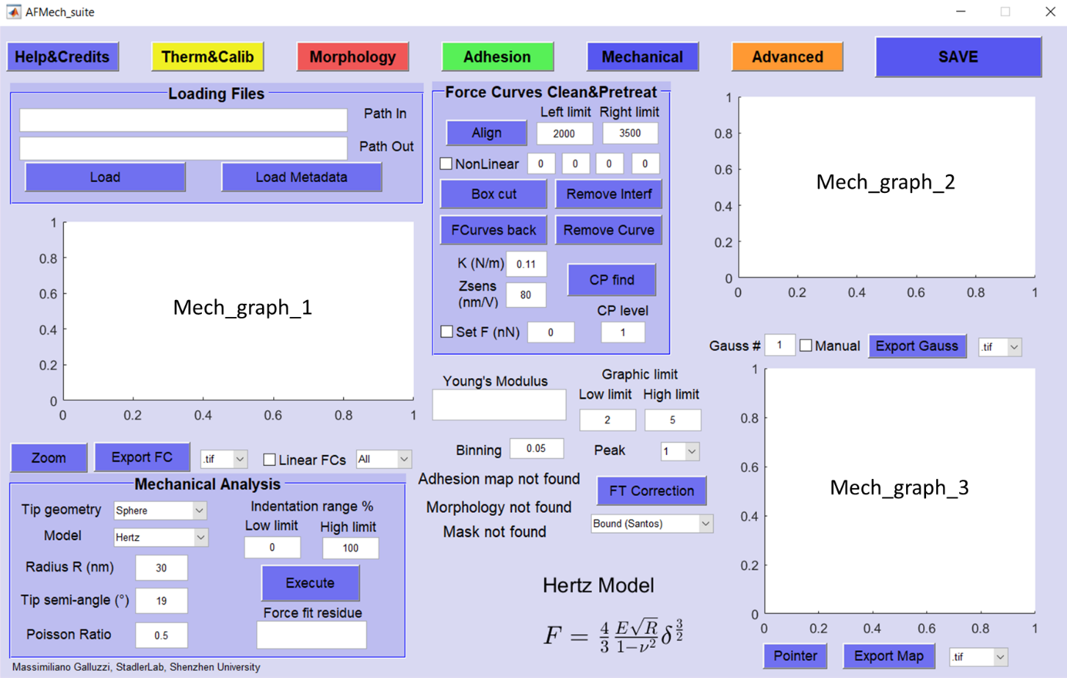

**Fig.14 Mechanical interface before loading data**

Mechanical interface is the core interface for the investigation of mechanical properties. Interface can be used to visualize and operate on raw FV file, focused on approaching part of force curves. Raw approaching FCs can be aligned, pretreated and fitted in order to produce quantitative Young’s modulus analysis thanks to histograms and Gaussian fitting procedures. Mechanical interface can inherit elastic constant **<K (N/m)>**, **<Zsens(nm/V)>** from Therm&Calib, Mask and topography from Morphology and adhesion force from Adhesion. Interacting mechanical analysis is especially useful when coupled with Morphology for finite thickness correction or with Adhesion for adhesive indentation problems.

In the panel ‘Loading Files’, **[Load]** button allows to load retracting force curves from raw FV files from AFM acquisition software (see fig.14). **[Load]** can use the complete identifier of the file (location directory + file name) contained in **<Path In>** edit. If **<Path In>** is empty or locating a directory, a menu choice is appearing in order to select the input file. **<Path Out>**, the edit string for the export/saving directory, is automatically updated accordingly with **<Path In>** selection, but can be user-overwritten in order to change the output directory.

After loading, raw FCs will be shown in Mech_graph_1: operations like baseline alignment, cleaning and interference removal are active on this graph. Quantitative histogram is shown in Mech_graph_2 while Young’s modulus map can be visualized (and exported) in Mech_graph_3. Here, vertical scale is user-controlled modifying ‘Low’ and ‘High’ values under **<Graphic limits>**.

## Force Curves pretreating and contact point

After loading, several operations can be performed to finally obtain Young’s modulus analysis (see fig.14). **[Align]** button is flattening the horizontal non-contact baseline defined between **<Left limit>** and **<Right limit>**.Long-range interactions, such as electrostatic, should be excluded during baseline alignment procedure. **[Box Cut]** allows creating a box on Mech_graph_1 in order to delete outliers points and cut undesired FC parts from analysis. Outliers are usually found in FV at the end of FCs due to morphological inhomogeneities or acquisition errors.

Especially when reflective samples are investigated, the laser reflected from cantilever is interfering with part of laser reflected from surface. Interference effect appears as a sinusoidal oscillation in the non-contact part (see fig.11A) leading to imprecisions if amplitude is not negligible. In Adhesion and Mechanical interfaces, FCs can be pretreated after **[Align]** in order to remove (or decrease) interference artifacts. **[Remove Interf]** button let the user select the non-contact part, far enough from jump-in event, defining the interval of sinusoidal fit (see fig.11B). Then, user must select by left-click a series of adjacent MAX and MIN from left to right direction, as shown in fig.11C; and a red line fit will appear after pressing ENTER. If the removal process is successful, non-contact part will appear as in fig.11D with no measurable oscillations.

If an approaching FC is not good, due to local sample defects or acquisition problems, it can be removed using button **[Remove bad FC]**. Selected ‘bad’ FC is substituted with average of first neighbors curves.

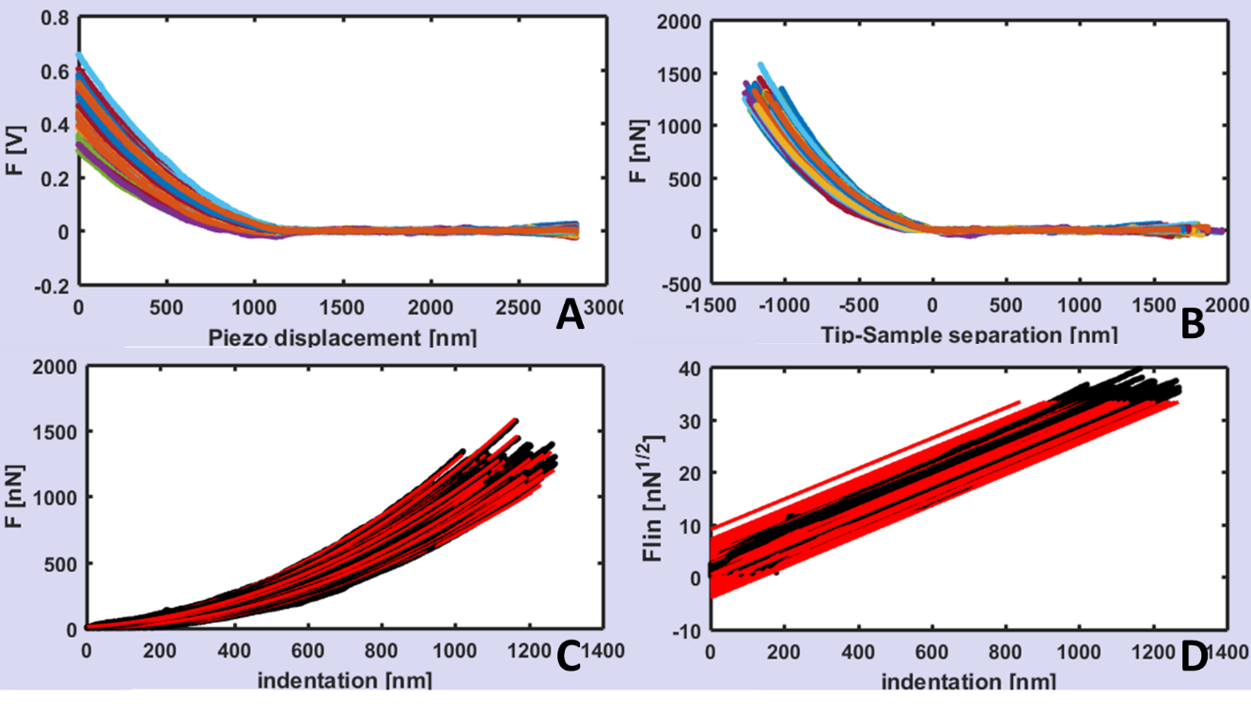

**Fig.15 A) Example of full set of FCs after loading and cleaning (sample PDMS calibration surface 2.5 MPa) B) FCs after [CP find] using non-contact noise. C) FCs after [Execute] using conical geometry: experimental data and Sneddon fit. D) linear representation of FCs using <linear> checkbox.**

After cleaning, FCs set could appear as in fig.15A. **[CP find]** is the second step in order to convert the curves in Force vs. Tip-sample distance, in particular to find the contact point between probe and surface. The procedure is using **<K (N/m)>**, **<Zsens(nm/V)>** from Therm&Calib interface or values can be user overwritten. The contact point can be found using 2 methods: non-contact noise (**<Set F>** unselected) or static threshold (**<Set F>** selected). If **<Set F>** is not selected, a histogram of the force axis is automatically calculated for each FC, and the non-contact part is observed as a sharply defined Gaussian distribution.11,12 The width of the Gaussian distribution represents the noise of non-contact part that must be overcome to find the contact point. The region of the FC above that level (**<CP level>**) is considered as the indentation for the fitting procedure. **<CP level>** is defining the number of widths above the non-contact background noise, after which the contact point is found. If **<Set F>** is selected, the contact point will correspond to the static threshold in nN, inputted near **<Set F>.** Static threshold finding is more fast but less precise than non-contact noise algorithm. After **[CP find]**, force curves will appear as in fig.15B and the negative part of tip-sample distance is just the indentation (see eq.4): indentation values and map is now uploaded in Morphology interface.

## Mechanical analysis

Mechanical analysis is performed by button **[Execute]** after choosing model and parameters corresponding to the AFM experiment. First, geometry of the probe **<Tip geometry>** and **<Model>** must be selected: a formula will appear describing the relation between force F (nN) and indentation  (nm). Models and geometries available are presented in Tab.1:

|  |  |  |  |
| --- | --- | --- | --- |
| **Geometry** | **Model** | **Equation(s)** | **Eq #** |
| Sphere | Hertz |  | 810 |
| Sphere | Sneddon |  | 913 |
| Sphere | DMT |  | 1014 |
| Sphere | JKR |  | 1115 |
| Sphere | Neo-Hookean |  | 1216 |
| Cone | Sneddon |  | 1313 |
| Cone | Adhesive |  | 1410 |
| Pyramid | Bilodeau |  | 1517 |
| Cylinder | Sneddon |  | 1613 |
| Hyperbol | Sneddon |  | 1718 |

**Tab.1 Formula and references for models of Mechanical interface.**

Where F is force,  indentation, E Young’s modulus, R probe radius,  averaged tip semi angle, RC cylinder radius,  Poisson’s ratio, a the radius of contact area and FAD the adhesion force.

Depending on the model probe radius R, averaged tip semi angle  and Poisson’s ratio  must be uploaded in the ‘Mechanical Analysis’ panel under, respectively, **<Radius R (nm)>**, **<Tip semi-angle(°)>** and **<Poisson Ratio>**. Mechanical interface allows the user to select the indentation interval in order to better focus the analysis on a specific percent range modifying ‘Low limit’ and ‘High limit’ values under **<Indentation range %>**. Finally, **[Execute]** performs the fitting and experimental data along with fitting will appear in Mech_graph_1 as shown in fig.15C; statistical analysis (see next paragraph) will be performed in Mech_graph_2 and Young’s modulus map will be updated in Mech_graph_3. Vertical scale is user-controlled modifying ‘Low’ and ‘High’ values under **<Graphic limits>,** considering log10 values. Near Mech_graph_3, **[Pointer]** button allows the selection of a single point on the map selecting the respective FC on Mech_graph_1 and changing the curve number under the graph. The reverse is possible, so changing the curve number; FC position on the map will be highlighted. Selecting ‘All’, Mech_graph_1 shows all the curves together; ‘Ave’ shows the average curve.

The discrepancy between experimental data and fitting will appear in ‘Mechanical Analysis’ panel under **<Force fit residue>** in order to evaluate quantitatively the goodness of model after fitting using the following formula:

$Res=\frac{1}{M}\sum_{j=1}^{M}{\sqrt{\frac{1}{N}\sum_{i=1}^{N}{{\left(F_{exp}\left(i,j\right)-F_{fit}\left(i,j\right)\right)}^{2}}}}$ eq (18)

where Fexp, Ffit, N and M are respectively experimental force curves, fitting , number of points in FC and number of FCs in the FV.

Finally, only for simple models in which Force is directly expressed in term of indentation (such as eq. 8, 10, 13, 15, 16 in tab.1), linearization is available checking **<Linear FCs>** box. Linearization convert the Force axis using the power law of F() in order to be linear with indentation. Example of the linearization procedure is presented in fig.15D.

## Statistical analysis

Statistical analysis in Adhesion interface can be visualized in Mech_graph_2, represented by the histogram of Young’s modulus in log10 scale. **<Binning>** allows changing the size of a single bin in histogram. **[Execute]** will automatically perform the statistical analysis after showing FCs with respective fittings. Like in Morphology and Adhesion interfaces, if histogram is showing more than a single peak, multi-Gaussian fit procedure will be the best choice to obtain quantitative information, selecting the number of peaks in **<Gaussians>**. Numerical results after data analysis can be selected modifying the peak number in **<Peak Selection>**. Especially for multi-Gaussian procedure, when software is not recognizing automatically distribution peaks, manual mode can be activated using checkbox **<Manual>**.

Manual mode is asking the user’s input to recognize multi-peaks positions. First, as shown in fig.16A, the interval used for Multi-Gaussian fitting must be selected (selection will be highlighted in blue). Then, starting positions must be individuated using left-click mouse: first, the center and height of distribution (triangles in fig.16B), then, width at semi-height of distribution (squares in fig.16B). The operation must be repeated for every distributions selected in **<Gaussians>**. Results could appear graphically as in fig.16C, while numerical values are will be shown under **<Young’s Modulus>** and controlled by **<Peak Selection>**. Value and error of **<Young’s Modulus>** are just the center and semi-width of the single-mode Gaussian distributions converted from lognormal to linear distribution using eq.19:

$E_{LIN}=\exp_{10}\left(E_{LOG}+\frac{\ln{10}}{2}σ_{LOG}^{2}\right) σ_{LIN}=E_{LIN}\sqrt{\exp_{10}\left(σ_{LOG}^{2}\right) -1}$ eq(19)

Where exp10 is exponential base 10, ELIN, LIN and ELOG LOG are respectively linearized Young’s modulus (Pa), linearized standard deviation (Pa); center and semi-width of lognormal distribution.

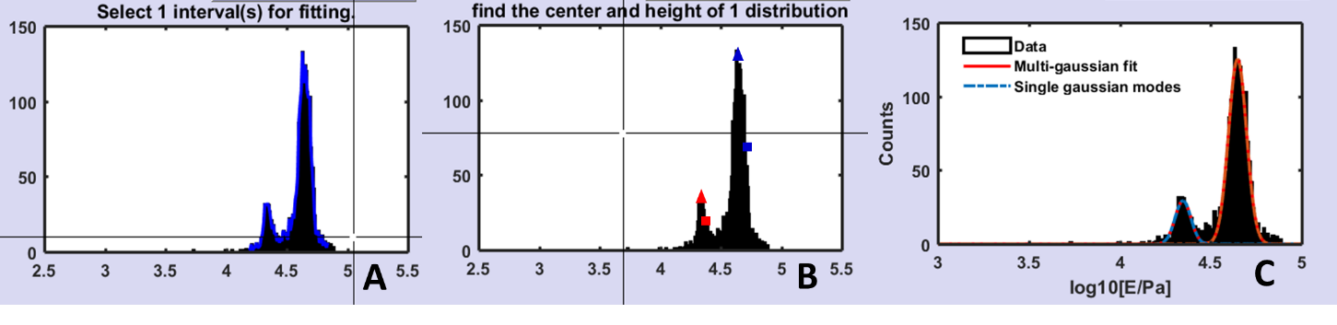

**Fig.16 A) Selection of interval before fitting in manual mode B) peaks finding procedure for each peak: first center and height (triangles) and width at semi-height (squares) C) Final results after multi-Gaussian fitting.**

## Finite Thickness Correction

Typically, all the contact mechanics models mentioned in Tab.1 are based on the assumption of indentation on infinite half-space, or at least the sample thickness should be much larger than total indentation. In case this condition is not satisfied, the influence of a rigid substrate can mislead the quantitative results of Young’s modulus. There are some works in literature related to the so-called finite thickness correction19-22; in particular Dimitriadis et al.22 developed an analytical approximate solution for spherical indenters, while Santos et al.19 for conical geometry.

|  |  |  |  |
| --- | --- | --- | --- |
| **Geometry** | **Boundary** | **Equation(s)** | **Eq #** |
| Sphere | Free |  | 2022 |
| Sphere | Bound |  | 2122 |
| Sphere | Semi |  | 2211 |
| Cone | Free |  | 2319 |
| Cone | Bound |  | 2419 |
| Cone | Semi | $$F=\frac{2}{π}\frac{E\tan{α}}{\left(1-ν^{2}\right)}δ^{2}\left[1+0.4481χ_{C}+0.9483{χ_{C}}^{2}+0.1345{χ_{C}}^{3}+0.1612{χ_{C}}^{4}\right]$$ | 25 |

**Tab.2 Formula and references for models with finite thickness correction.**

Where F is force,  indentation, E Young’s modulus, R probe radius,  averaged tip semi angle,  Poisson’s ratio, h thickness of sample and S, C represent the adimensional correction parameters:

$χ_{S}=\frac{\sqrt{Rδ}}{h} χ_{C}=\frac{δ\tan{α}}{h}$ eq(26A, B)

It should be pointed out that for large h and shallow indentation, finite thickness correction is not influencing standard results.

At the moment in AFMech_suite, finite thickness correction is only available for spherical geometry applied to Hertz model (eq.8) and for conical geometry applied to Sneddon model (eq.13). As shown in tab.2, different boundary condition can be used: frictionless (free), non-slipping (bound) or intermediate (semi). The choice depends on the degree of binding between sample and rigid substrate going from well-bound to free-moving. Selecting the proper geometry will activate the finite thickness correction button **[FT Correction]** along with the possibility to select the appropriate boundary conditions.

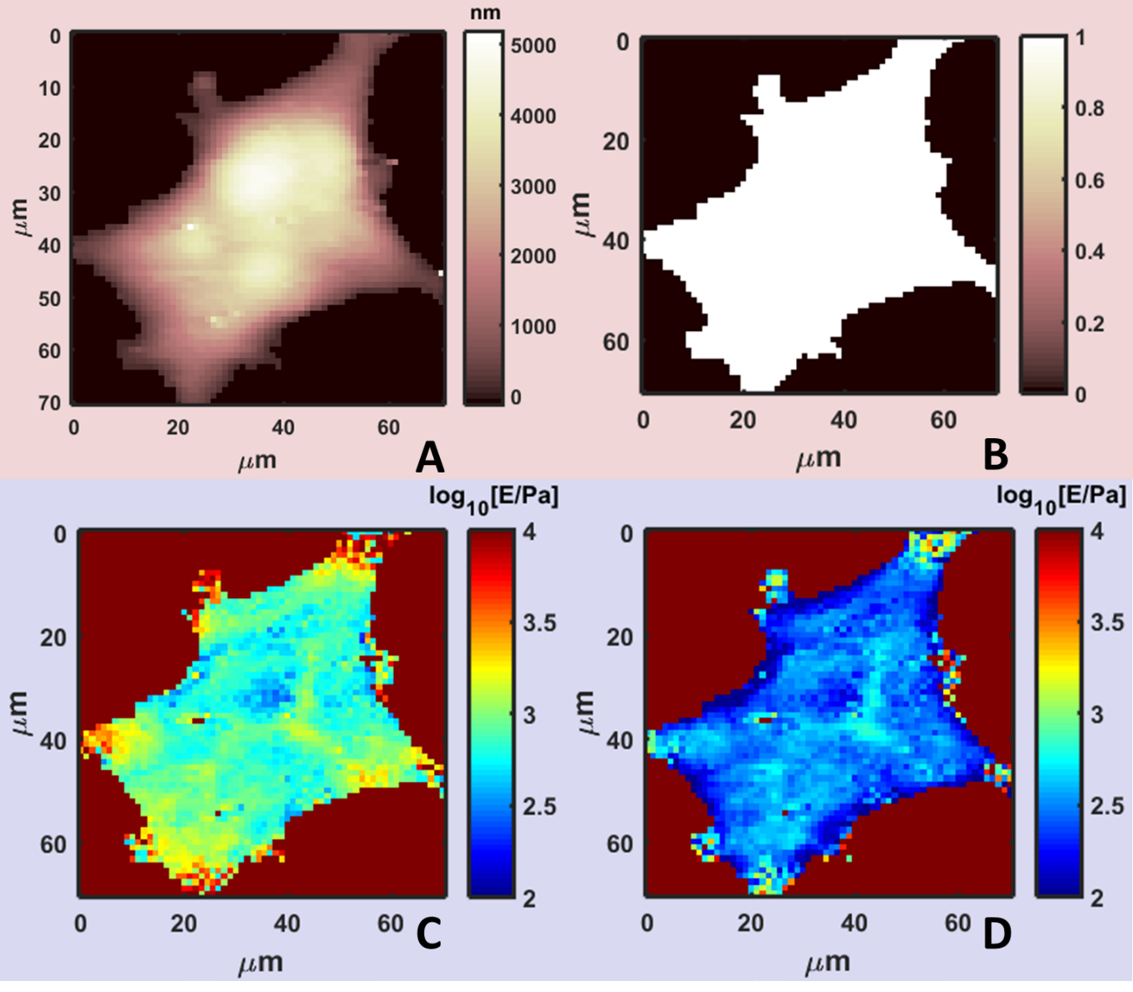

**Fig.17 A) Real morphology of MDA_MB_231 cell B) logical mask excluding point of substrate C) Young’s modulus map using [20% 40%] circa 2-4nN. D) Young’s modulus map after finite thickness correction, same interval.**

Finite thickness correction requires also a proper morphological analysis in order to flatten the substrate and obtain the appropriate height map (fig.17A). Moreover, the substrate must be selected and recognized by masking it (fig.17B) in Morphology interface. In this way, no calculation will be performed on substrate but it will be reference height for the correction. If no mask is found, finite thickness correction will not be available.

Generally, after standard mechanical analysis (fig.17C) as describe in the previous sections, finite thickness correction can be performed pressing **[FT Correction]**. New Young’s modulus map will be available (fig.17D), as well statistical analysis and FCs analysis.

## Export & Save

Graphics produced in Adh_graph_1, Adh_graph_2 and Adh_graph_3 can be exported during any stage of analysis using buttons **[Export FC],** **[Export Gauss]** and **[Export Map]**. Exported files are automatically saved in directory designated by respective **<Path Out>** edit.

Retracting force curves can be exported using **[Export FC],** with the possibility to choose ‘All’, ‘average’ or ‘curve #’: formats available are listed below:

1. .tif *Tagged Image File Format* no compression, 300 dpi
2. .fig *Matlab Figure*
3. .mat *Matlab Data*, structure containing Matlab variables
4. .txt *Plain text with no special formatting,* data and/or fitting in columns
5. .xls *Excel* table, data and/or fitting in columns
6. .opj *Origin* table and graphs

If Matlab software is not available .fig and .mat files cannot be opened. Origin export in .opj is not creating or opening if Origin is not installed on the machine.

For Gaussian analysis, using **[Export Gauss],** formats available are listed below:

1. .tif *Tagged Image File Format* no compression, 300 dpi
2. .fig *Matlab Figure*
3. .mat *Matlab Data*, structure containing Matlab variables
4. .txt *Plain text with no special formatting,* data and/or fitting in columns
5. .xls *Excel* table, data and/or fitting in columns
6. .opj *Origin* table and graphs

If Matlab software is not available .fig and .mat files cannot be opened. Origin export in .opj is not creating or opening if Origin is not installed on the machine.

Using **[Export Map]**, images will be exported in the following formats:

1. .tif *Tagged Image File Format* no compression, 300 dpi
2. .fig *Matlab Figure*
3. .mat *Matlab Data*, structure containing Matlab variables
4. .tif(3D) *Tagged Image File Format*, 300 dpi, 3D representation of map
5. .fig(3D) *Matlab Figure*, 3D representation of map

Saving data is possible only through Mechanical interface using **[Save].** A snapshot of the analysis, variables and structures are saved and named *#filename#*_metadata inside **<Path Out>** directory. All data in the 5 interfaces will be saved in 1-click: saving will also work with partial analysis allowing the user to pause analysis and restart later opening metadata file.

Metadata can be loaded only with **[Load Metadata]** in ‘Loading Files’ panel. Some operations, like **[FCurves back]** or **<Linear FCs>**, will not be available and reloading raw files is required.

# Advanced Interface

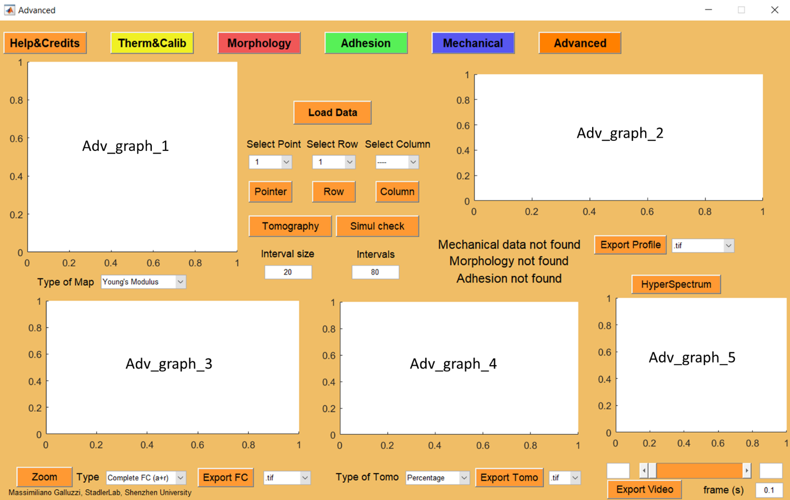

**Fig.18 Advanced interface before loading data**

Advanced interface is the post-processing interface able to investigate mechanical properties in a deeper way, for example visualize profiles, tomography, perform a comparison with simulations or external files, and calculate the Young’s modulus hyperspectrum. Advanced is the only interface not loading external raw data, as it uses results directly after Morphology, Adhesion and Mechanical analysis.

**[Load Data]** button allows loading all data analysis performed in Morphology, Adhesion and Mechanical (see fig.18). Further modifications in other interfaces will not influence tomography until **[Load Data]** is pressed again. If interface cannot found Mechanical analysis data, it will not be possible to start.

After loading, maps will appear in Adv_graph_1 with **<Type of Map>** allowing to choose between Young’s modulus, Real morphology and Adhesion. Profile of row #1 will display in Adv_graph_2, while FC #1 will show in Adv_graph_3. Force curve number or row/column number can be customized after **[Load Data]**.

Vertical scale is inherited from ‘Low’ and ‘High’ values in **<Graphic limits>** from Mechanical, Morphology and Adhesion interfaces.

## Profile analysis

After loading, maps will appear in Adv_graph_1 with the possibility to select Young’s Modulus map (fig.19A), Real morphology map (fig.19B) and Adhesion map (fig.19C) using **<Type of Map>** choice. Automatically, depending by the selected map the respective profile of row #1 will be displayed in Adv_graph_2. Vertical scale of maps and profile is the same in Morphology, Adhesion and Mechanical: after modification **[Load Data]** is going to update Advanced interface.

For profile analysis, a single row or column can be selected directly by numbering using **<Select Row>** or **<Select Column>**. Using button **[Row]** or **[Column]** a cursor will appear on Adv_graph_1 in order to target a row or column for analysis.

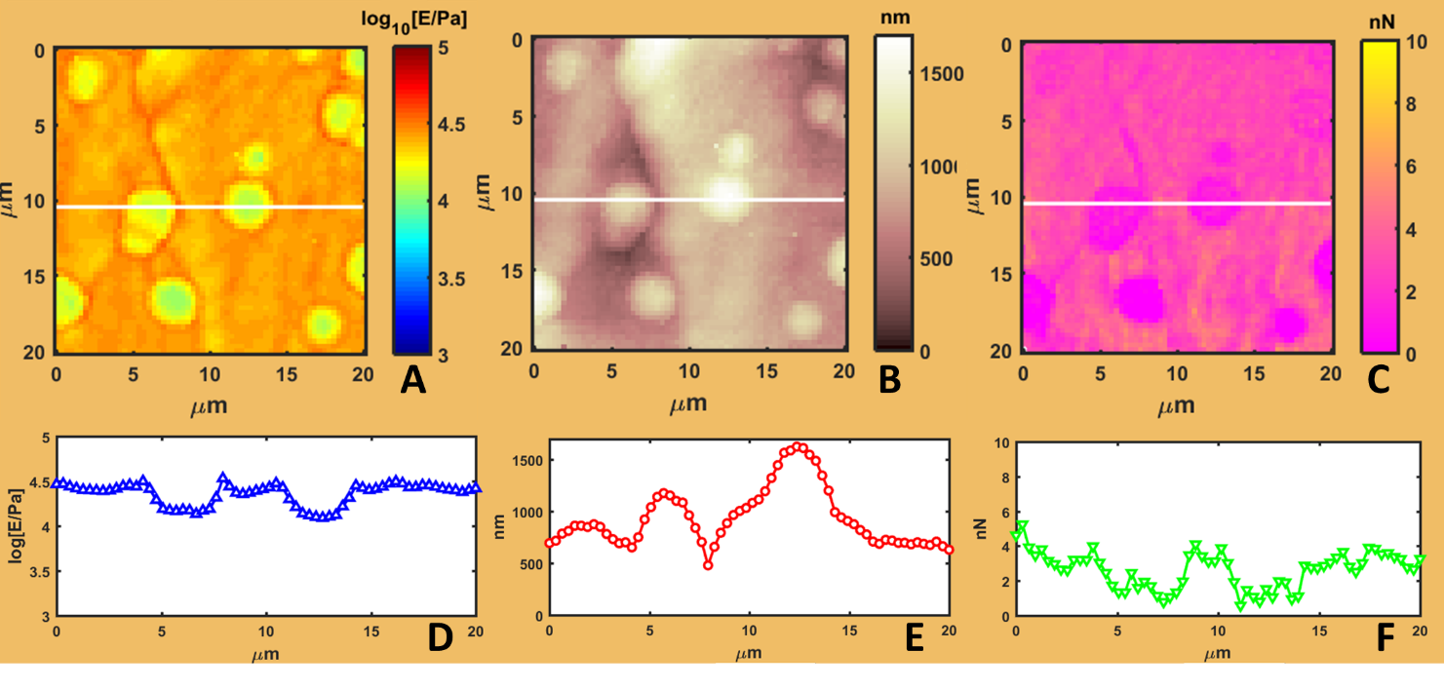

**Fig.19 Hydrogel matrix with hard spherical inclusions measured by colloidal probe in water. A) Young’s modulus map, B) Real morphology map, C) Adhesion map. D) Young’s modulus profile of white line E) Morphological profile F) Adhesion force profile.**

Examples of profiles of Young’s modulus (fig.19D), real morphology (fig.19E) and adhesion force (fig.19F) are presented here in correspondence with maps.

## Force curves analysis

**[Load data]** is also triggering a single FC (initially #1) to be shown in Adv_graph_3 with the possibility to select 3 views: complete force curve approaching and retracting parts (fig.20A); Force vs. indentation curve (fig.20B) and Young’s Modulus vs. indentation curve (fig.20C). For this analysis, a single FC can be selected directly by numbering using **<Select Point>.** Using button **[Pointer]** a cursor will appear on Adv_graph_1 in order to target a single point on the map. The selection can be performed indifferently on the 3 maps.

The retracting part of the complete force curve is aligned in order to match the respective approaching curve. Young’s modulus vs. indentation curve is a repetition of analysis already performed in Mechanical interface: it is shown here for simulation comparison purpose (see next paragraph).

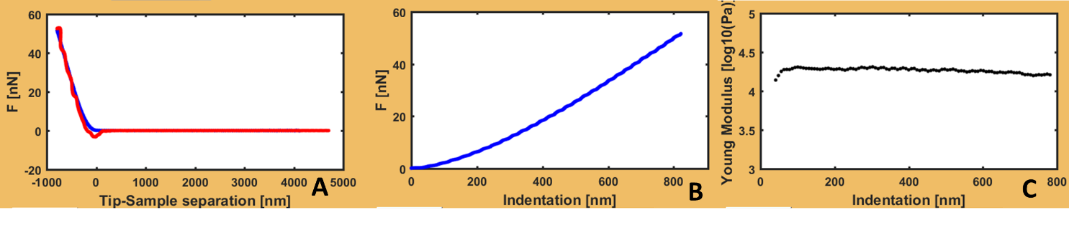

**Fig.20 Force curve on hydrogel surrounding matrix A) Example of complete force curves approaching + retracting parts. B) Force vs. indentation curve C) Young’s Modulus vs. indentation after division in 100 intervals with 15% indentation width.**

The Young’s Modulus vs. indentation curves is representing how the Young’s modulus changes when indentation varies. The process is similar to a derivative of F vs. indentation: standard FC is divided in intervals, which number and amplitude is controlled by **<Intervals>** and **<Interval size>**, and Young’s modulus is calculated by fitting on those segments. Intervals can overlap each other if the **<Interval size>** multiplied per number of intervals is bigger than 100%: results will appear less noisy but with less resolution on internal variability. The resulting curve (fig.20C) is the basepoint for simulation comparison, tomography and hyperspectrum analysis. About the Young’s modulus vs. indentation curve some studies can be found in literature.23,24

## Simulation comparison

Simulation comparison is an option in order to compare experimental data with external files containing single FC data, for example a simulation output.

The external file must be prepared or converted strictly in a .txt format with the following structure: first column must be indentation in nm units; second column must be force in nN units.

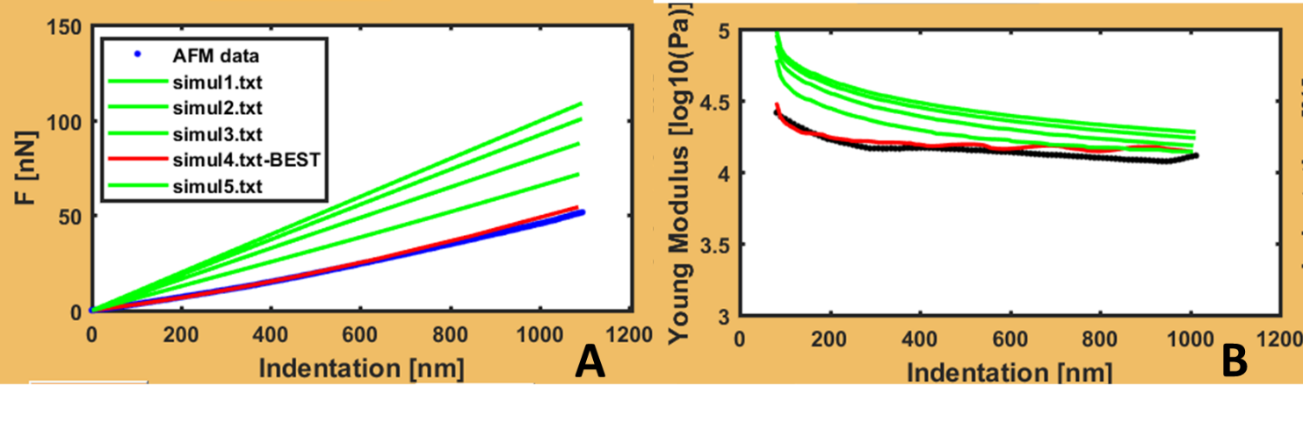

**Fig.21 Visualization of FC on hard spherical inclusion on hydrogel in comparison with simulated curves A) simulation comparison shown on F vs indentation curves, B) simulation comparison shown on Young’s modulus vs. indentation.**

After **[Load Data]**, the comparison with external FC can be done using **[Simul Check]**. A menu will be shown in order to navigate and select external .txt files one by one. Cancel button in the menu terminates the selection and will show the comparison in Adv_graph_3. Comparison can be evaluated on F vs indentation (fig.21A) or on Young’s modulus (E) vs. indentation (fig.21B). Automatically the software is selecting the best external file that minimize the deviations sum acting on E vs.  as:

eq (26)

Where N is the number of intervals dividing FC and Eexp, Esimul are the modulus calculate on different intervals for experimental and external data. Minimization is performed on modulus E in order to evaluate with the same weight data at shallow and deep indentation.

The external data that is minimizing eq.26 will be highlighted in red and signed as BEST (see fig.21).

## Tomography and Hyperspectral analysis

The possibility to divide FC in intervals and to find the Young’s modulus (E) vs. indentation () opened to the possibility to perform Young’s modulus tomography and hyperspectral analysis. Tomography is representing the E vs.  (as in fig.20C and fig.21B) along a section of the map, in this case a column or a row. Fig.22A represents the tomography of the white row and profiles of fig.19, normalize don maximum indentation so that indentation y-axes does not depend on morphology. Fig.22B is the same tomography after coupling with morphology and using absolute indentation. Young’s modulus tomography, especially in representation as fig.22B, can provide information on the mechanical properties relative to internal part of the sample: useful for vertically and horizontally heterogeneous samples. Operation can be activated after selecting a row or a column and using **[Tomography]** button. For every new selected line, **[Tomography]** should be refreshed. Young’s modulus tomography will be shown in Adv_graph_4.

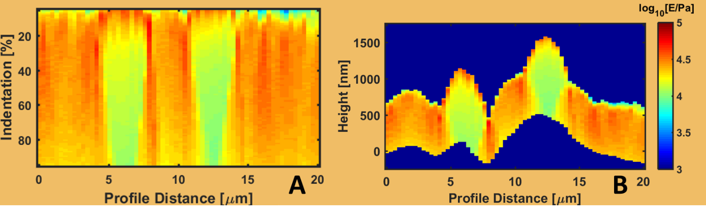

**Fig.22 A) Tomography of white line in fig.19 using 100 intervals with 15% indentation width. A) Tomography relative to percent indentation, B) tomography relative to height after coupling with morphology analysis.**

Hyperspectral analysis is E vs.  operation for each FC in the FV map. The resulting hyperspectrum is a 3D map, so for the visualization a slidebar with a cursor allows to explore the modulus varying indentation.

Hyperspectral analysis is the longest operation of the software depending on size of FV, number of intervals and type of model (for example more complex hyperboloid will take more time than Hertz). Finally, as explained in the next section hyperspectrum can be exported as a video, showing variation of modulus with time (time will be proportional to indentation).

## Exporting

Graphics produced in Adv_graph_2, Adv_graph_3, Adv_graph_4 and Adv_graph_5 can be exported during any stage of analysis using buttons **[Export Profile],** **[Export FC]**, **[Export TOMO]** and **[Export Video]**. Exported files are automatically saved in directory designated by **<Path Out>** edit of Mechanical interface. It is not possible to export maps of Adv_graph_1 here, but only in Mechanical, Morphology and Adhesion interfaces.

Profile data can be exported using **[Export Profile],** with the possibility to choose ‘Young’s Modulus’, ‘Real morphology’ or ‘Adhesion’ in **<Type of Map>**; and any row or column from map: formats available are listed below:

1. .tif *Tagged Image File Format* no compression, 300 dpi
2. .fig *Matlab Figure*
3. .mat *Matlab Data*, structure containing Matlab variables
4. .txt *Plain text with no special formatting,* data and/or fitting in columns
5. .xls *Excel* table, data and/or fitting in columns
6. .opj *Origin* table and graphs

If Matlab software is not available .fig and .mat files cannot be opened. Origin export in .opj is not creating or opening if Origin is not installed on the machine.

Force curve analysis, with eventually simulation comparison, can be exported using **[Export FC]** and choosing the **<FC type>**: ‘Complete FC (a+r)’,’Force vs. indent’ or ‘Modulus vs. indent’.Formats available are listed below:

1. .tif *Tagged Image File Format* no compression, 300 dpi
2. .fig *Matlab Figure*
3. .mat *Matlab Data*, structure containing Matlab variables
4. .txt *Plain text with no special formatting,* data and/or fitting in columns
5. .xls *Excel* table, data and/or fitting in columns
6. .opj *Origin* table and graphs

If Matlab software is not available .fig and .mat files cannot be opened. Origin export in .opj is not creating or opening if Origin is not installed on the machine.

Using **[Export TOMO]**, tomography images can be exported choosing **<FC type>** ‘relative’ or ‘morphological’ with the following formats:

1. .tif *Tagged Image File Format* no compression, 300 dpi
2. .fig *Matlab Figure*
3. .mat *Matlab Data*, structure containing Matlab variables
4. .tif(3D) *Tagged Image File Format*, 300 dpi, 3D representation of map
5. .fig(3D) *Matlab Figure*, 3D representation of map

Finally, using **[Export Video]**, the hyperspectral analysis of Young’s modulus will be saved in a video using value of **<Frame(s)>** as the time of a single frame in seconds. Exported video will be .avi with H.264 compression.

# References

1 Schillers, H. *et al.* Standardized Nanomechanical Atomic Force Microscopy Procedure (SNAP) for Measuring Soft and Biological Samples. *Sci Rep-Uk* **7**, 5117, doi:10.1038/s41598-017-05383-0 (2017).

2 Butt, H. J. & Jaschke, M. Calculation of Thermal Noise in Atomic-Force Microscopy. *Nanotechnology* **6**, 1-7, doi:Doi 10.1088/0957-4484/6/1/001 (1995).

3 Sader, J. E., Lu, J. & Mulvaney, P. Effect of cantilever geometry on the optical lever sensitivities and thermal noise method of the atomic force microscope. *Rev Sci Instrum* **85**, 113702, doi:10.1063/1.4900864 (2014).

4 Heim, L.-O., Rodrigues, T. S. & Bonaccurso, E. Direct thermal noise calibration of colloidal probe cantilevers. *Colloids and Surfaces A: Physicochemical and Engineering Aspects* **443**, 377-383, doi:10.1016/j.colsurfa.2013.11.018 (2014).

5 Sader, J. E., Yousefi, M. & Friend, J. R. Uncertainty in least-squares fits to the thermal noise spectra of nanomechanical resonators with applications to the atomic force microscope. *Rev Sci Instrum* **85**, 025104, doi:10.1063/1.4864086 (2014).

6 Lozano, J. R., Kiracofe, D., Melcher, J., Garcia, R. & Raman, A. Calibration of higher eigenmode spring constants of atomic force microscope cantilevers. *Nanotechnology* **21**, 465502, doi:10.1088/0957-4484/21/46/465502 (2010).

7 Pirzer, T. & Hugel, T. Atomic force microscopy spring constant determination in viscous liquids. *Rev Sci Instrum* **80**, 035110, doi:10.1063/1.3100258 (2009).

8 Proksch, R., Schaffer, T. E., Cleveland, J. P., Callahan, R. C. & Viani, M. B. Finite optical spot size and position corrections in thermal spring constant calibration. *Nanotechnology* **15**, 1344-1350, doi:Doi 10.1088/0957-4484/15/9/039 (2004).

9 Cappella, B. & Dietler, G. Force-distance curves by atomic force microscopy. *Surface Science Reports* **34**, 1-+, doi:Doi 10.1016/S0167-5729(99)00003-5 (1999).

10 Borodich, F. M. The Hertz-Type and Adhesive Contact Problems for Depth-Sensing Indentation. **47**, 225-366, doi:10.1016/b978-0-12-800130-1.00003-5 (2014).

11 Puricelli, L., Galluzzi, M., Schulte, C., Podesta, A. & Milani, P. Nanomechanical and topographical imaging of living cells by atomic force microscopy with colloidal probes. *Rev Sci Instrum* **86**, 033705, doi:10.1063/1.4915896 (2015).

12 Galluzzi, M. *et al.* Space-resolved quantitative mechanical measurements of soft and supersoft materials by atomic force microscopy. *NPG Asia Materials* **8**, e327, doi:10.1038/am.2016.170 (2016).

13 Sneddon, I. N. The relation between load and penetration in the axisymmetric boussinesq problem for a punch of arbitrary profile. *International Journal of Engineering Science* **3**, 47-57, doi:<http://dx.doi.org/10.1016/0020-7225(65)90019-4> (1965).

14 Derjaguin, B. V., Muller, V. M. & Toporov, Y. P. Effect of contact deformations on the adhesion of particles. *J Colloid Interf Sci* **53**, 314-326, doi:10.1016/0021-9797(75)90018-1 (1975).

15 Johnson, K. L., Kendall, K. & Roberts, A. D. Surface Energy and the Contact of Elastic Solids. *Proceedings of the Royal Society A: Mathematical, Physical and Engineering Sciences* **324**, 301-313, doi:10.1098/rspa.1971.0141 (1971).

16 Zhang, M. G., Cao, Y. P., Li, G. Y. & Feng, X. Q. Spherical indentation method for determining the constitutive parameters of hyperelastic soft materials. *Biomech Model Mechanobiol* **13**, 1-11, doi:10.1007/s10237-013-0481-4 (2014).

17 Bilodeau, G. G. Regular Pyramid Punch Problem. *J Appl Mech-T Asme* **59**, 519-523, doi:Doi 10.1115/1.2893754 (1992).

18 Sun, Y. J., Akhremitchev, B. & Walker, G. C. Using the adhesive interaction between atomic force microscopy tips and polymer surfaces to measure the elastic modulus of compliant samples. *Langmuir* **20**, 5837-5845, doi:10.1021/la036461q (2004).

19 Santos, J. A. C., Rebelo, L. M., Araujo, A. C., Barros, E. B. & de Sousa, J. S. Thickness-corrected model for nanoindentation of thin films with conical indenters. *Soft Matter* **8**, 4441-4448, doi:10.1039/c2sm07062f (2012).

20 Vichare, S., Inamdar, M. M. & Sen, S. Influence of cell spreading and contractility on stiffness measurements using AFM. *Soft Matter* **8**, 10464-10471 (2012).

21 Lin, D. C., Shreiber, D. I., Dimitriadis, E. K. & Horkay, F. Spherical indentation of soft matter beyond the Hertzian regime: numerical and experimental validation of hyperelastic models. *Biomech Model Mechan* **8**, 345-358, doi:10.1007/s10237-008-0139-9 (2009).

22 Dimitriadis, E. K., Horkay, F., Maresca, J., Kachar, B. & Chadwick, R. S. Determination of Elastic Moduli of Thin Layers of Soft Material Using the Atomic Force Microscope. *Biophysical Journal* **82**, 2798-2810, doi:10.1016/S0006-3495(02)75620-8 (2002).

23 Roduit, C. *et al.* Stiffness Tomography by Atomic Force Microscopy. *Biophysical Journal* **97**, 674-677, doi:10.1016/j.bpj.2009.05.010 (2009).

24 Roduit, C. *et al.* Stiffness tomography exploration of living and fixed macrophages. *J Mol Recognit* **25**, 241-246, doi:10.1002/jmr.2184 (2012).